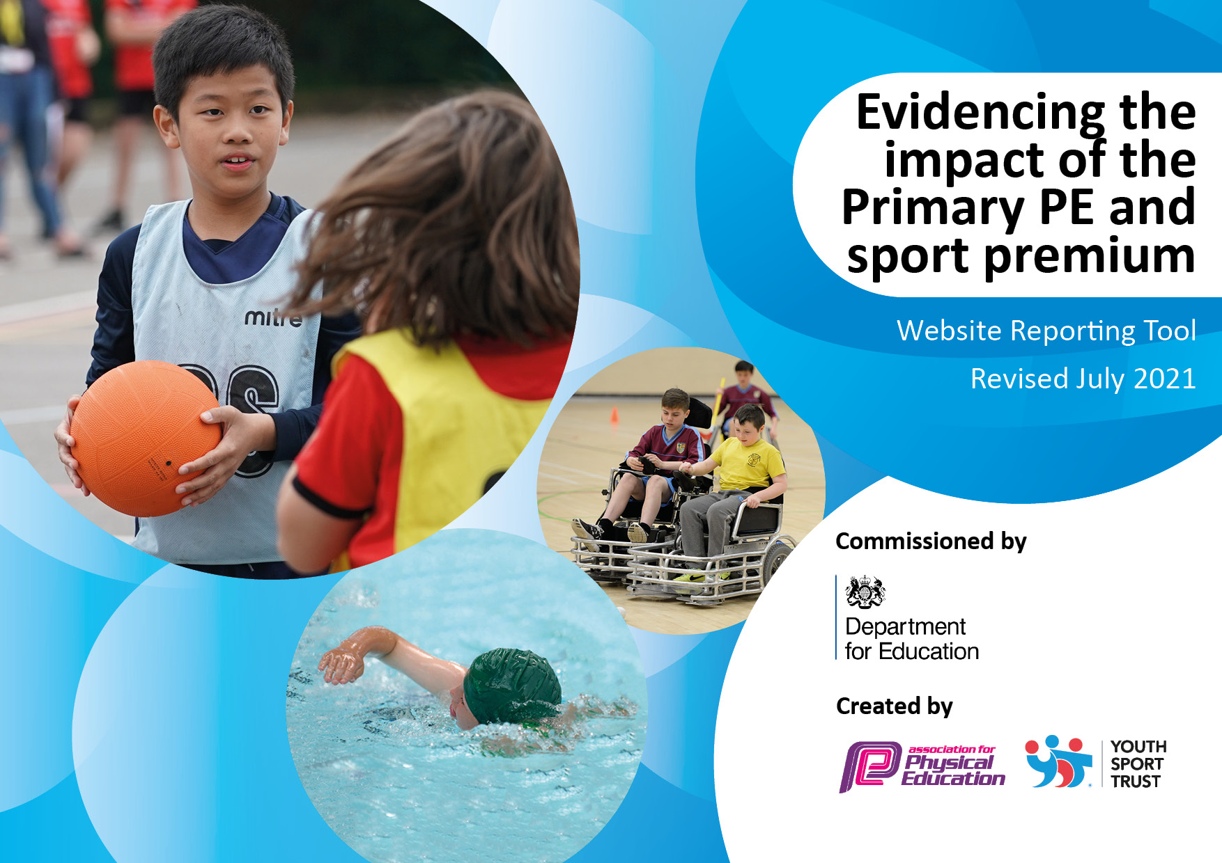
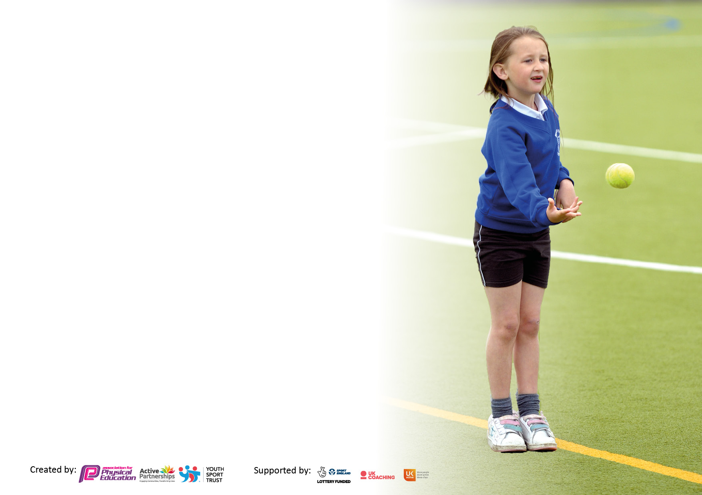

It is important that your grant is used effectively and based on school need. The Education Inspection Framework makes clear there will be a focus on ‘whether leaders and those responsible for governors all understand their respective roles and perform these in a way that enhances the effectiveness of the school’.

Under the Quality of Education Ofsted inspectors consider:
Intent - Curriculum design, coverage and appropriateness
Implementation - Curriculum delivery, Teaching (pedagogy) and Assessment
Impact - Attainment and progress

To assist schools with common transferable language this template has been developed to utilise the same three headings which should make your plans easily transferable between working documents.

Schools must use the funding to make additional and sustainable improvements to the quality of Physical Education, School Sport and Physical Activity (PESSPA) they offer. This means that you should use the Primary PE and sport premium to:

- Develop or add to the PESSPA activities that your school already offer
- Build capacity and capability within the school to ensure that improvements made now will benefit pupils joining the school in future years
- The Primary PE and sport premium should not be used to fund capital spend projects; the school’s budget should fund these.

Pleasevisitgov.ukfortherevisedDfEguidanceincludingthe5keyindicatorsacrosswhichschoolsshoulddemonstrate animprovement.Thisdocumentwillhelpyoutoreviewyourprovisionandtoreportyourspend.DfEencouragesschools to use this template as an effective way of meeting the reporting requirements of the Primary PE and sport premium.

We recommend you start by reflecting on the impact of current provision and reviewing the previous spend.

Schools are required to publish details of how they spend this funding, including any under-spend from 2019/2020, as well as on the impact it has on pupils’ PE and sport participation and attainment. All funding must be spent by 31st July 2022.

We recommend regularly updating the table and publishing it on your website throughout the year. This evidences your ongoing self-evaluation of how you are using the funding to secure maximum, sustainable impact. Final copy must be posted on your website by the end of the academic year and no later than the 31st July 2021. To see an example of how to complete the table please click HERE.
Created by: Supported by:

Funding details

Total amount carried over from 2019/20 | £0
Total amount allocated for 2020/21 | £17640
How much (if any) do you intend to carry over from this total fund into 2021/22? | £0
Total amount allocated for 2021/22 | £17750
Total amount of funding for 2021/22. To be spent and reported on by 31st July 2022. | £17750
Swimming Data

Meeting national curriculum requirements for swimming and water safety.

N.B. Complete this section to your best ability. For example you might have practised safe self-rescue techniques on dry land which you can then transfer to the pool when school swimming restarts.
Due to exceptional circumstances priority should be given to ensuring that pupils can perform safe self rescue even if they do not fully meet the first two requirements of the NC programme of study
What percentage of your current Year 6 cohort swim competently, confidently and proficiently over a distance of at least 25 metres?  N.B. Even though your pupils may swim in another year please report on their attainment on leaving primary school at the end of the summer term 2021.  Please see note above | We are unable to report on this as swimming was suspended due to Covid, and the pool remains closed.
What percentage of your current Year 6 cohort use a range of strokes effectively [for example, front crawl, backstroke and breaststroke]?  Please see note above | We are unable to report on this as swimming was suspended due to Covid, and the pool remains closed.
What percentage of your current Year 6 cohort perform safe self-rescue in different water-based situations? | See above
Schools can choose to use the Primary PE and sport premium to provide additional provision for swimming but this must be for activity over and above the national curriculum requirements. Have you used it in this way? | In previous years we have done so, but see above.

Action Plan & Budget Tracking

Academic Year: 2020/21 | Total fund allocated: |  |  | Date Updated:
Key indicator 1: The engagement of all pupils in regular physical activity – Chief Medical Officers guidelines recommend that primary school pupils undertake at least 30 minutes of physical activity a day in school |  |  |  |  |  |  | Percentage of total allocation:
 |  |  |  |  |  |  | %
Intent | Implementation |  |  |  |  | Impact
Your school focus should be clear what you want the pupils to know and be able to do and about  what they need to learn and to  consolidate through practice: | Make sure your actions to achieve are linked to your intentions: |  |  | Funding allocated: |  | Evidence of impact: what do pupils now know and what can they now do? What has changed? | Sustainability and suggested next steps:
Active, breakfast club, breaks and lunchtimes  Incorporate PE into other lessons | Rota use of sports pitch.  Rota use of playground spaces.  Increase Kingball markings as this is a popular sport.  KS1 pupils undertake fitness activities during registration.  Renew and replace play equipment  Children take part in Wake & Shake activities each morning during breakfast club  Teachers look for wider curriculum opportunities:  - Science (body, air pollution)  - Maths (data analysis and statistics) |  |  | £9500 |  | Children are active throughout playtimes and lunchtimes, all engaged in a physical activity.  Children will participate in short fun physical games that raise their heart rates | Small budget for replacement of equipment as larger equipment and markings are in place
Key indicator 2: The profile of PESSPA being raised across the school as a tool for whole school improvement |  |  |  |  |  |  | Percentage of total allocation:
 |  |  |  |  |  |  | %
Intent | Implementation |  |  |  |  | Impact
Improved confidence in teaching of PE by all teaching staff  Importance of being healthy taught and discuss in all PE lessons  Teachers attempting to incorporate physical activity into the wider curriculum  Participation with SUSTRANS to try to promote more healthier ways of travel to school. | Having a specific part of the new curriculum which looks at healthy lifestyles and the importance of Physical Activity (Healthy Lifestyles, Personal and Social impacts, Leadership development)  Ideas from other subject leads and PE lead to be shared on how PE could be incorporated into the wider curriculum  Work with charity SUSTRANS to take part in different celebration days (Big Pedal, Play Street) |  |  | £800 |  | Teachers feel more confident in teaching PE  Teachers discussing the importance of PE in school and also children’s wider lives  Increase in children travelling to school other that driving  Seeing children take part in more physical lessons (maths and science)  Children are able to discuss the importance of daily physical activity and the benefits of it | Once systems in place, PE Lead can maintain them.
Key indicator 3: Increased confidence, knowledge and skills of all staff in teaching PE and sport |  |  |  |  |  |  |  | Percentage of total allocation:
 |  |  |  |  |  |  |  | %
Intent |  | Implementation |  |  | Impact
Complete the PE scheme of work and support all teachers in its implementation.  New teacher and sports coach observations |  | Training and support sessions for teachers.  New teachers to be shown the PE scheme of work and PE Lead to model lessons if necessary  Free football sessions for girls every Wednesday | £3800 |  | New teachers feeling more confident to teach PE  If needed, teacher observations of PE lessons taught  Increase in girls participating in sport at school |  |  | PE scheme of work is in place and to be used each year.
Key indicator 4: Broader experience of a range of sports and activities offered to all pupils |  |  |  |  |  |  |  | Percentage of total allocation:
Intent |  | Implementation |  |  | Impact
Increase after school club sporting opportunities.  Participation in inter school competitions  Participate in local SEND sports cluster |  | Hockey Club weekly  Judo or football club weekly  Release of adults to take children to competitions  Equipment for specific sports (those not taught in the curriculum)  Release of adults to take children to | £2850 |  | Children become part of a team, learn a new physical skill, take part in competitions. |  |  | Maintain links with other local primary schools and the local community
Key indicator 5: Increased participation in competitive sport |  |  |  |  |  |  |  | Percentage of total allocation:
 |  |  |  |  |  |  |  | %
Intent |  | Implementation |  |  | Impact
Participation in inter school competitions  Children participate in inter class competitions |  | Release of adults to take children to the sports grounds  Release time for staff to:  - Create timetables  - Organise teams | £800 |  | Children will have attended numerous competitions in a range of sports  Children enjoy taking part in competitions amongst their peers. Understand that sometimes we win and sometimes we lose and that it is still fun to participate. |  |  | Link with other primary schools to link in with local competitions

Signed off by
Head Teacher: | T Bennett
Date: | July 2022
Subject Leader: | K Blake
Date: | July 2022
Governor: | R Precey
Date: | July 2022

