**Half-Termly Curriculum Overview for Year 1 Summer 2 2023 June-July**

**Ms Abrahams, Ms Sharena, Mr Hussain & Mr Muhammad**

**English**

We will be exploring the features of Science fiction story. We will be writing our own science fiction stories based on the book ‘Aliens Love Underpants’. We will be engaging in drama to retell the story. The children will also be writing a recount of their trip to The Natural History Museum.

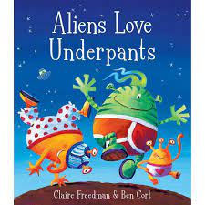

.

**Maths**

We will be learning about Position and Direction, Place Value and Time. Children should practically turn objects, shapes and themselves in different directions but do not need to describe the direction of the turns. The children will build on their previous learning of numbers to 50 and continue grouping in 10s to counting quicker and more efficient. Children will be counting forwards and backwards within 100.

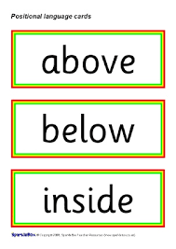

**Religious Education**

Rosh Hashanah and Yom Kippur

Key Question:

Are Rosh Hashanah and Yom Kippur important to Jewish children?

**Topic**

**Unit: The Great Fire of London**

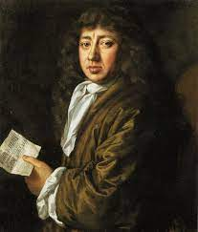

We will be learning about The Great Fire of London which happened in 1666. The children will find out about the events that led to the fire and what happened then and order the events on a timeline. They will learn about the famous people who lived then and the important jobs they played including King Charles II and Samuel Pepys.

**PSHE:** **Changing Me**

In this topic, the children will learn about how their body has changed since they were a baby. We will identify the main body parts and how to respect the differences between boys and girls.

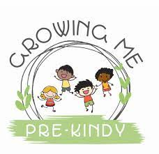

International Primary Curriculum (IPC)

Over the next 7 weeks we will be following a unit of work on a theme that focuses on “Active Planet – Volcanoes and Earthquakes”. During this unit we will be focusing on **History and Geography.**

In History, we’ll be:

* Learning about the main characteristics of people and cultures that existed during the Stone Age, Bronze Age and Iron Age
* Finding

In Art, we’ll be:

• Creating our own prehistoric cave paintings

• Making and decorating pottery, based on one of the periods we have explored

In Technology we’ll be:

• Exploring the types of foods that the ﬁrst farmers would have grown

• Updating dishes that early settlers may have eaten

In IPC, we’ll be:

• Finding out how we can work together to learn new skills and achieve our goals

**Music** 

The class will be singing songs with Mr Daggett on Wednesdays. They will also learn to play the African drums.

**Physical Education**

Our unit will be Attack and Defend and Judo. P.E will take place every Mondays and Tuesdays. Please remember to send in your child’s PE kit. (T-shirt, joggers, trainers).

**Cooking and Nutrition** **(CaN)** – Mondays!

We will be using all skills learnt to make seasonal salads using fresh herbs.

**Computing:**

Our unit will be …



**SCIENCE**

***Unit:* Holiday**

We will be looking similarities and differences between materials and fabrics and exploring questions like, why are items such as lip salve, sun cream and sunglasses important? We will be looking at living things in the sand and sea and the import roles jobs done by Marine Biologists.

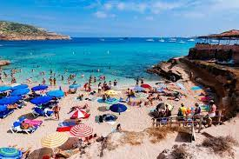

**Partnership with Parents**

**Maths**: Please help your child to complete maths homework on **Sumdog**. You should have your child’s log in details.

**Reading**. Children are expected to read every night for at least 20 minutes. Don’t forget to write a comment in your child’s Reading Record book when you have read with them. Books will be changed on Fridays. We would like all bookbags to be in school every day. Thank you!

**Homework:** Homework will be set on **Sumdog** every week. It is expected to be completed by all the children. **Times Table Rock stars** should be accessed by children to learn the 2,5,10 times tables only. Please support your child to practice them 4-5 times a week. They will also have many activities to do on Purple Mash. Any problems? Please let us know! We will also continue to send out weekly spellings for the children to practice.