**Half-Termly Curriculum Overview for Year 2 January/ February - Spring 2024**

**Ms Safia, Mrs Zainab, Mrs Sharena & Mr Hussain**

**English**

In Literacy we will be reading a range of stories by significant authors like Anthony Browne. We will be writing short stories and focusing on building on what makes a good narrative. Year 2 will be focussing on time adverbials, verbs, adjectives, adverbs nouns and suffixes.

The children will also re-tell a class version and invent our own stories.

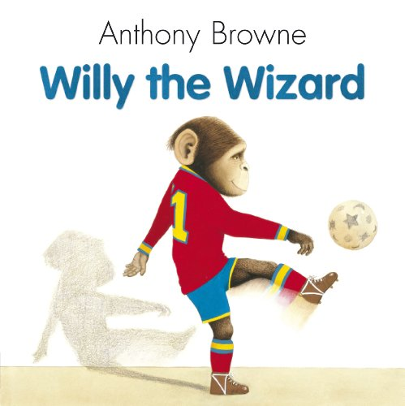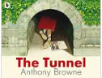

**Maths**

**Money & Multiplication/Division**

We will start the term learning about money. We will be learning the value of coins and notes, then adding up the total amount. We will also find different ways to create a total amount using different coins. After money, we will begin division and multiplication. We will be making equal groups, adding them and making arrays. We are focussing on multiplication tables for groups of 2’s, 5’s and 10’s. The children will also be solving word problems related to multiplication.

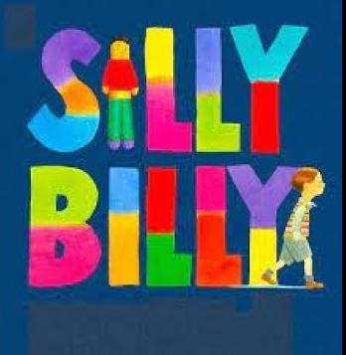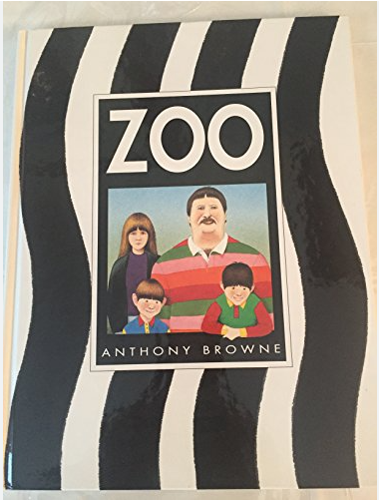

**Religious Education**

Theme: Judaism - Celebration

**Key question for this enquiry:** Why are they having a party?

**Topic – History**

**Key question for this enquiry:** What impact has Florence Nightingale had on hospitals?

For this term, children will be looking at the impact Florence Nightingale had on hospitals. We will look into her life, the impact and changes she made on hospitals and the work she has done to help modern hospitals. We also be looking at the impact her work has on people’s lives in the past and present.

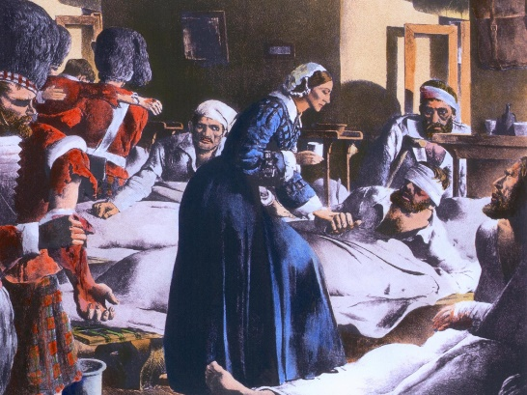

International Primary Curriculum (IPC)

Over the next 7 weeks we will be following a unit of work on a theme that focuses on “Active Planet – Volcanoes and Earthquakes”. During this unit we will be focusing on **History and Geography.**

In History, we’ll be:

* Learning about the main characteristics of people and cultures that existed during the Stone Age, Bronze Age and Iron Age
* Finding

In Art, we’ll be:

• Creating our own prehistoric cave paintings

• Making and decorating pottery, based on one of the periods we have explored

In Technology we’ll be:

• Exploring the types of foods that the ﬁrst farmers would have grown

• Updating dishes that early settlers may have eaten

In IPC, we’ll be:

• Finding out how we can work together to learn new skills and achieve our goals

**PHSE**

**Dreams and Goals**

Outcomes: The children will be setting their own goals and think about how to achieve them. They will also look at what makes a good learner.

**K**

**Music**

The whole class will continue to work on the African drumming techniques as they learn new and challenging rhythms and song patterns. We also have singing lessons every Wednesday with Mr Bruce.

Physical Education – Games

Outcomes: Children will be able to learn the different. Skills required for games such as basketball and tag. They will also be doing Judo this half term with coach. **Please bring your PE Kit on Tuesday. Judo will be on TUESDAY.**

**Please bring your PE Kit on a Wednesday and swimming costume on Friday**

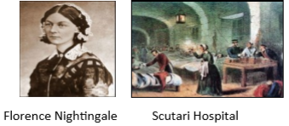

**Computing**

For this term, children will be looking at spreadsheets, data and how to analyse it.

**Cooking and Nutrition** **(CaN)** – THURSDAY!

We will be cooking what is in season and key skills will be to use a tin opener, heat ingredients in a saucepan, to safely boil. We will also be cooking tantilising African dishes!

**Partnership With Parents**

**Maths**: Please help your child to practise their 2, 3, 4, 5 and 10 tables. Times tables Rockstars is a fun way to engage children and this will be introduced to the children this term.

**Reading:** Children are expected to read every night for at least 20 minutes. Please write a comment in your child’s Reading Record when you have read with them. Books will be changed on **Fridays.**

**Homework:** Homework will be set on Purple mash every week on a Friday. It is expected to be completed by the following Friday. Any problems? Let us know!

**Science – Mini Worlds**

Children will be exploring and comparing the differences between things that are living and that are dead or have never been alive. To identify habitats and micro-habitats to which they are suited; to gain an understanding of a simple food-chain and sources of food.

