**Half-Termly Curriculum Overview for Year 2 Summer 1 2023**

**Mrs Reader and Ms Safia**

**English**

In Literacy we will be focussing on writing Chronological Reports on Hedgehogs focussing on headings/sub-headings, the use adjectives to describe, including facts, using sentence openers, and use of generalisers (like so/most/many/some). The next unit will be Explanation Texts, looking at and gaining an understanding of the Life-cycle of the Frog. They will listen to facts about the Life cycle of the Frog

and discuss the stages of the life-cycle, making hats and split-pin frogs to kick-start this unit! They will also learn the different parts of the frog’s body, functions and begin to compile some structured writing, giving explanations.

**Maths** We will be looking at:

**Topic**

**PHSE:** **Relationships**

Outcomes: The children will look at positive ways to solve friendship problems when they occur, they will learn how to express their appreciation for the people in their special relationships and I recognise who can help them in their family, school and community.

**K**

**Religious Education**

We will be focussing on

**The Key Question is**: Does going to the Mosque give Muslims a sense of belonging?

International Primary Curriculum (IPC)

Over the next 7 weeks we will be following a unit of work on a theme that focuses on “Active Planet – Volcanoes and Earthquakes”. During this unit we will be focusing on **History and Geography.**

In History, we’ll be:

* Learning about the main characteristics of people and cultures that existed during the Stone Age, Bronze Age and Iron Age
* Finding

In Art, we’ll be:

• Creating our own prehistoric cave paintings

• Making and decorating pottery, based on one of the periods we have explored

In Technology we’ll be:

• Exploring the types of foods that the ﬁrst farmers would have grown

• Updating dishes that early settlers may have eaten

In IPC, we’ll be:

• Finding out how we can work together to learn new skills and achieve our goals

**Music**

The whole class will continue to work on the African drumming techniques as they learn new and challenging rhythms and song patterns.

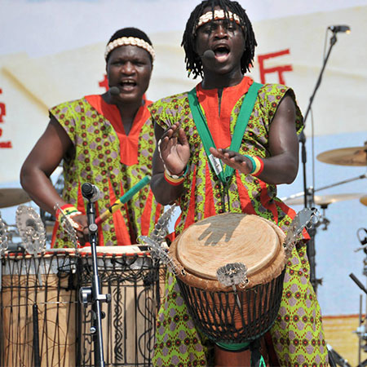

**Physical Education – Games**

Outcomes: Children will be able to learn the different. Skills required for games such as basketball and tag with our sports coach. **Please bring your PE Kit on Monday.**

**Please bring your PE Kit on a Wednesday and swimming costume on Friday**

**Computing**

We will be exploring 2paint on Purple Mash to create our own portraits inspired by famous artists including Picasso and Kandinsky.

**Cooking and Nutrition** **(CaN)** – TUESDAYS!

We will be cooking what is in season and rustling up dishes in addition to, challenging ourselves to use up store cupboard staples.

**Partnership With Parents**

**Maths**: Please help your child to practise their 2, 3, 4, 5 and 10 tables. Times tables Rockstars is a fun way to engage children.

**Reading:** Books will be changed on Fridays. Children are expected to read every night for at least 20 minutes. Please write a comment in your child’s Reading Record book when you have read with them.

**Homework:** Homework will be set on Sumdog every week on a Friday. It is expected to be completed by the following Friday. Any problems? Let us know!

**Science – Mini Worlds**

Children will be learning about ‘Young Gardner’s, naming plant parts, functions of plant parts, naming different plants e.g. vegetables, flowers. They’ll also be growing from seeds and bulbs, looking at conditions for growth.