**Half-Term Curriculum Overview for Year 4 Summer Term 1 April/May 2023**

**Ms Hendy, Ms Liz, Mrs. Grundy**

**Literacy**

.

To identify the features of a myth

To create an original myth

To dramatise and role-play Egyptian myths

Outcomes: Children will be able to:

* create settings, mythical creatures and a plot
* use expanded noun phrases to extend their descriptive writing
* present their work to an audience

**Numeracy**

Children will learn how to:

- Compare numbers with the same number of decimal places up to two decimal places.

- Round decimals with one decimal place to the nearest whole number

- Recognise and write decimal equivalents to a quarter, half and three quarters.

- Find the effect of dividing a one or two digit number by 10 or 100, identifying the value of the digits in the answer as ones, tenths and hundredths.

- Estimate, compare and calculate different measures, including money in pounds and pence.

Temples, Tombs

International Primary Curriculum: Temples, Tombs and Treasures

**In History:**

Children will:

- Know about the main events, dates and

characteristics of Ancient Egypt

- Know about the lives of people in those periods

- Know about the main similarities and differences between Ancient Egypt and Ancient Sumer

- Be able to give some reasons for particular events and changes

**In Art:**

Children will:

- Know how Ancient Egyptian artists used forms, materials and processes to decorate their tombs, buildings and belongings

Ancient Egypt

**Topic: Ancient Egypt**

Children will:  
- Compare and contrast the lives of Ancient Egyptians   
with our modern lives  
- Learn about Ancient Egyptian religions, including the Egyptian Pantheon of Gods, burial rites including mummification and the building of the pyramids as well as Ancient Egyptian beliefs about the afterlife  
- Learn how the geography of the River Nile helped shaped their civilization through developments of technologies like irrigation  
- Learn about famous archaeologists such as Howard Carter and consider if their methods were ethical, including discussion on modern museum ethics

[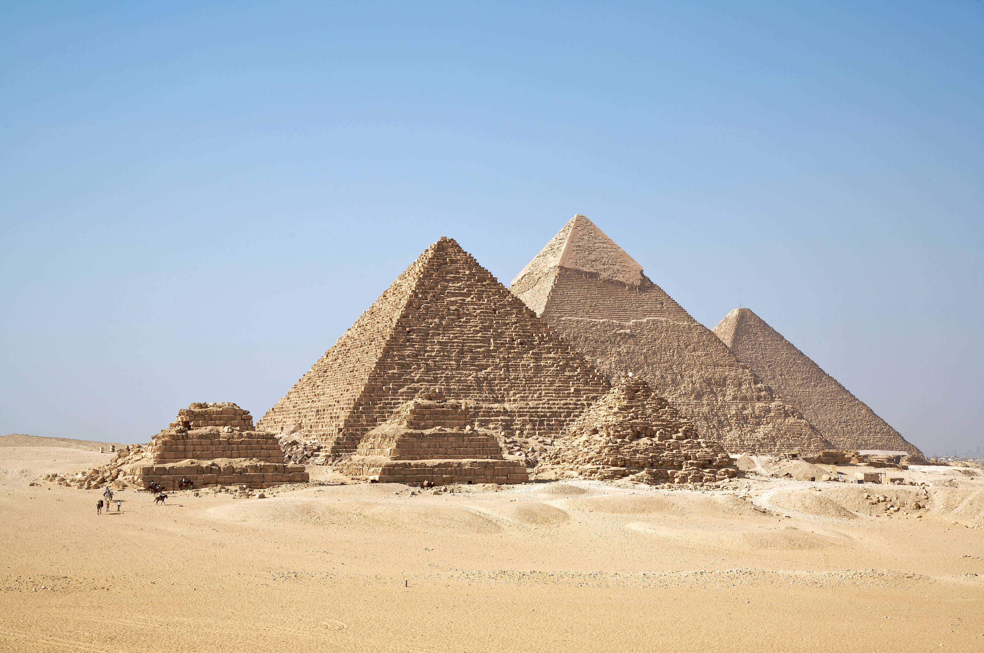](http://www.google.co.uk/url?sa=i&rct=j&q=egyptian+pyramids&source=images&cd=&cad=rja&uact=8&ved=0CAcQjRw&url=http://en.wikipedia.org/wiki/Egyptian_pyramids&ei=1-sTVZvOAYHDPcyigJgL&bvm=bv.89217033,d.ZGU&psig=AFQjCNHb4vBtLwy6h8W41F3i3A9Pn9T7Vg&ust=1427455317236435)

**RE: Christianity**

Our focus question is ‘Why are there four Gospels and how are they relevant to Christians today?’ The children will explore the similarities and differences within the Four Gospels of Matthew, Mark, Luke and John and discuss reasons for why they were written.

**PHSE: Relationships**

Children will develop their understanding of the web of relationships they are part of and their roles and responsibilities within.

**PE: PE on Monday & Thursday  
Judo on Wednesday**

Children will continue to:

- develop team skills in games

- develop resilience during team games

- to understand that losing is an important part of team games.

**Children should bring in their kits on Mondays, to be taken home on Fridays**

**French**

To recognise and say numbers 21-31.

Food & Drinks

**Computing**

To explore how font size and style can affect the impact of a text.

• To use a simulated scenario to produce a news report.

• To use a simulated scenario to write for a community campaign.

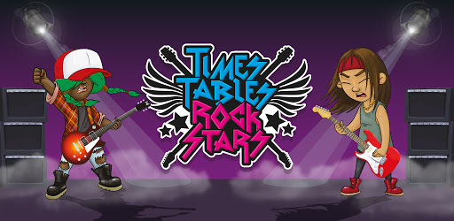

**Music**

Drumming with Michael on Thursdays. Singing with Mr. Daggett on Wednesdays

**Science - Power It Up!**

Children learn about electricity.

We will explore:

- Uses of electricity

- The importance of safety around electricity

- How to construct simple circuits and interpret diagrams

**Parents How Can You Help?**

Children should be practising with **Times Tables Rockstars** regularly.

**Reading:** Children are expected to read every night and bring their Guided Reading books in their yellow book bag to school every day.