The Federation of St John’s Bethnal Green &

St Paul’s Whitechapel CE Primary Schools

Enjoy teaching. Make a difference. Advance your career.

The governors of St John’s Bethnal Green &
St Paul’s Whitechapel CE Primary Schools are seeking to appoint a
SENCo (0.8 FTE)
Teacher Main/Upper Pay Scale
(To start September 2023)
St John’s and St Paul’s Whitechapel CE Primary Schools are multi-cultural, one-form entry primary schools in the heart of London. Both offer fantastic children, supportive parents, effective governors and a commitment to ongoing professional development. We are looking for creative and hardworking teachers who will enjoy the challenge of working in a diverse community.
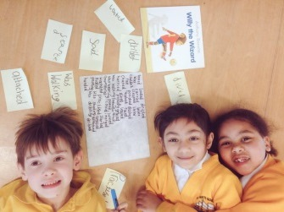
We can give you:
- The respect that good teachers deserve.
- £1,000 bonus at the end of a successful first year
- Up to £500 towards a laptop/ tablet in your second year.
- Commitment to your personal well-being.

The successful candidate will have:
- QTS and the National SENCO award.
- at least two years’ experience as a SENCo.
- enthusiasm and an excellent rapport with young people
- the ability and passion to forge strong links with parents and the whole community.
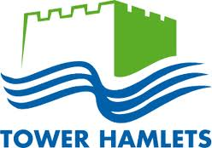
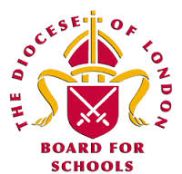
- a strong commitment to inclusion with high expectations for all learners.
- strong interpersonal skills, high expectations and the ability to inspire

We would welcome and encourage potential candidates to visit our schools. Please telephone or email to arrange this or for an application pack.

We are committed to safeguarding and promoting the welfare of children and young people and expect all staff and volunteers to share this commitment. Appointment subject to enhanced DBS check.

Applications close: Friday 9th June
Interviews: Thursday 15th June

Please note that we do not accept applications from agencies.

For an application pack, please contact Lisa Potten admin@st-johns.towerhamlets.sch.uk, 0208 980 1142

St John’s CE Primary School, Peel Grove, Bethnal Green, London E2 9LR
www.st-johns.towerhamlets.sch.uk

St Paul’s Whitechapel CE Primary School, Wellclose Square, London E1 8HY
www.st-pauls.towerhamlets.sch.uk

