The Federation of St John’s Bethnal Green &

St Paul’s Whitechapel CE Primary Schools

The governors of St John’s Bethnal Green &
St Paul’s Whitechapel CE Primary Schools are seeking to appoint a
SENIOR ADMINISTRATION OFFICER
Scale 6
(To start as soon as possible)
St John’s and St Paul’s Whitechapel CE Primary Schools are multi-cultural, one-form entry primary schools in the heart of London. Both offer fantastic children, supportive parents, effective governors and a commitment to ongoing professional development.
This post is based at St Paul’s Whitechapel CE Primary School. We are looking for a Senior Administrative Officer to oversee the school’s administrative functions including the school office, pupil records, attendance and to assist the Federation Business manager with finance and personnel.

The successful candidate will:
- have experience of working in an office environment;
- be a team worker possessing the skills needed to contribute to effective partnerships with children, staff, parents and governors;
- be proactive in taking initiative and working independently;
- be committed to acting with integrity, honesty, loyalty and fairness to safeguard the assets, financial probity and reputation of the school;
- be able to establish and develop appropriate relationships with all stakeholders;
- be able to communicate effectively, both verbally and in writing, with a variety of audiences;
- have strong interpersonal skills, high expectations and the ability to inspire.
We are committed to safeguarding and promoting the welfare of children and young people and expect all staff and volunteers to share this commitment.
This appointment is subject to enhanced DBS check.

Applications close: Friday 22nd April, 9:00 am
Interviews: Tuesday 26th April

For an application pack, please contact:
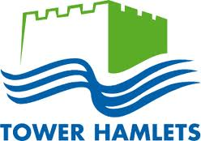
Lisa Potten lpotten.211@lgflmail.org 0208 980 1142

St John’s CE Primary School, Peel Grove, Bethnal Green, London E2 9LR
www.st-johns.towerhamlets.sch.uk

St Paul’s Whitechapel CE Primary School, Wellclose Square, London E1 8HY
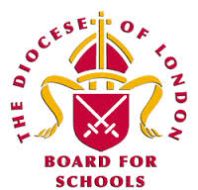
www.st-pauls.towerhamlets.sch.uk

