**Half-Termly Curriculum Overview for Year 1 Summer 1 2023 April- May**

**Ms Abrahams, Ms Sharena, Mr Hussain & Mr Muhammad**

**English**

We will be exploring the features of a non-chronological report. We will be learning about The Great fire of London and writing our own non-chronological report on this. We will be engaging in role play to describe the events which took place. We will be creating a school information brochure too!

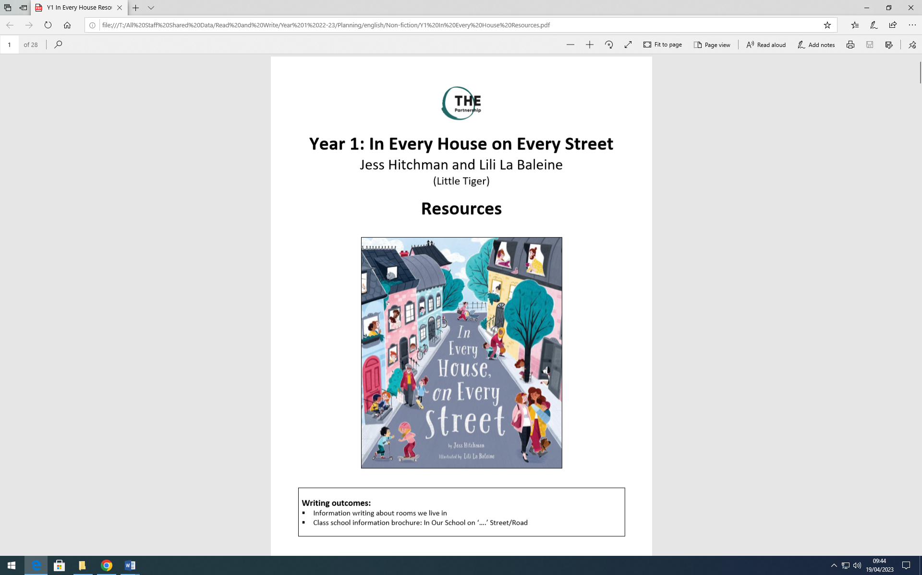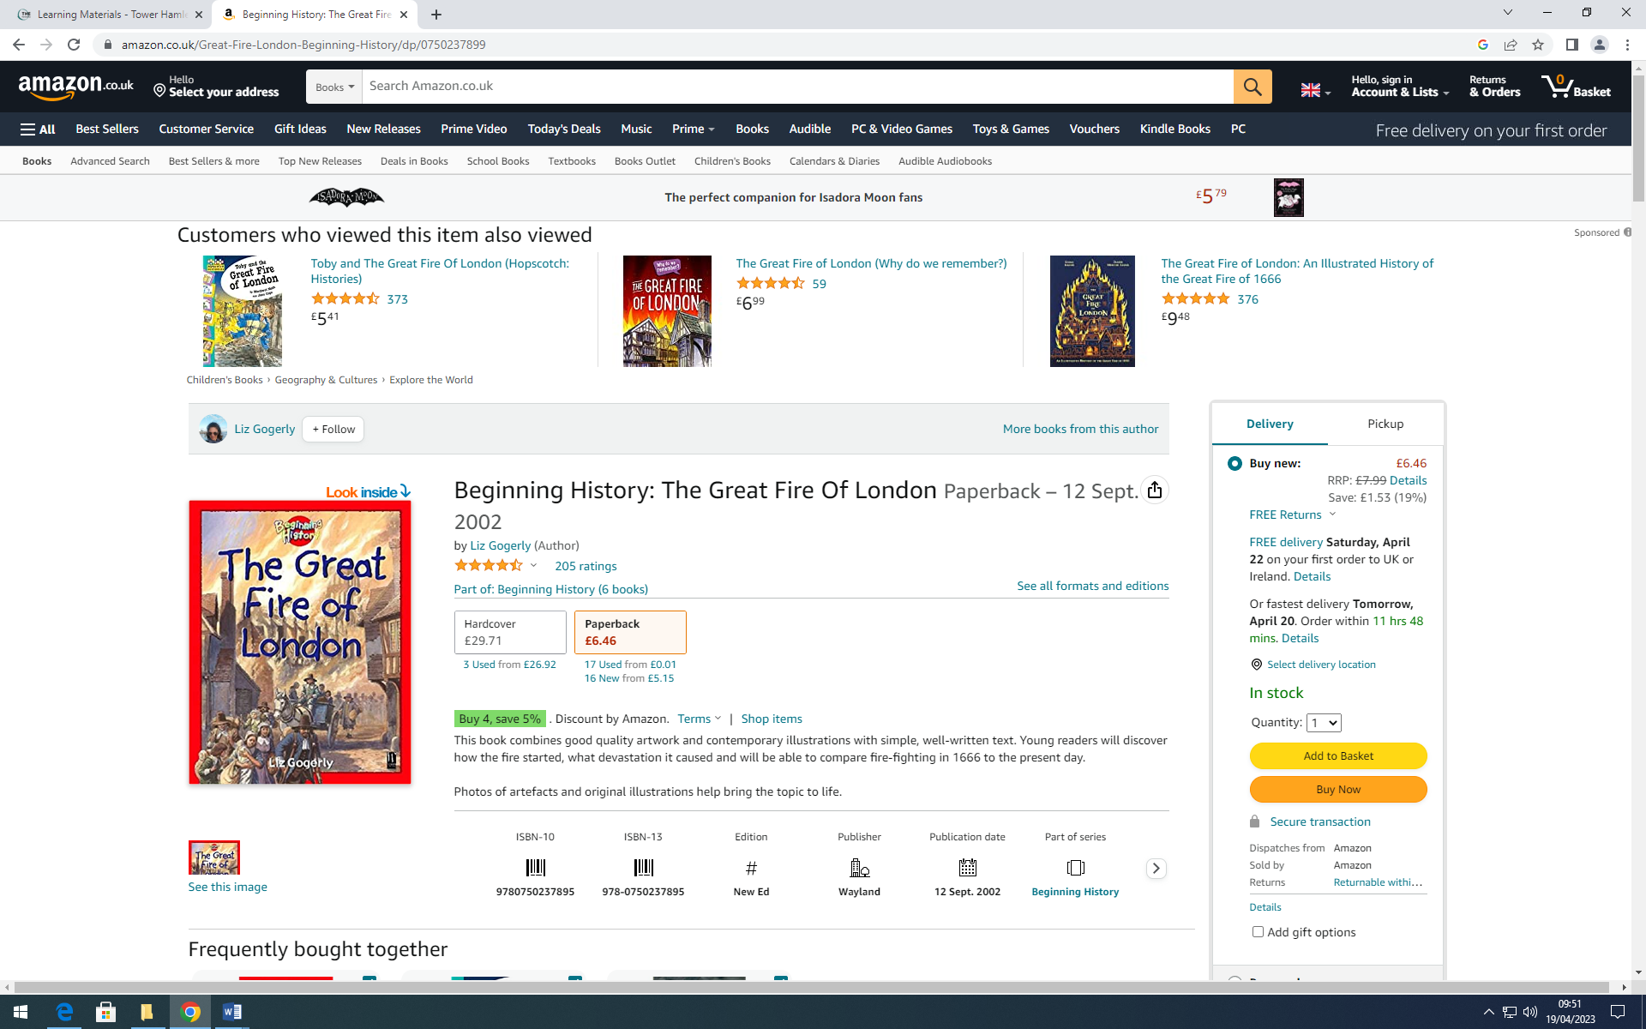

.

**Maths**

Our unit will be Multiplication and Division. The children will learn how to count in steps of 2, 5 and 10. They will be counting objects in groups of 2s, 5s and tens and relating it to their division facts. They will relate this to their timetables and recall their timetables facts with increasing fluency.

 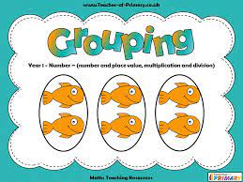

**Religious Education-** Shabbat

Key Question:

Is Shabbat important to Jewish children?

Religion: Judaism

**Topic-Growing Food**

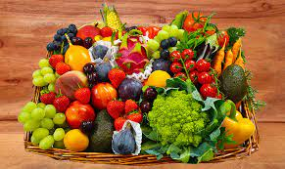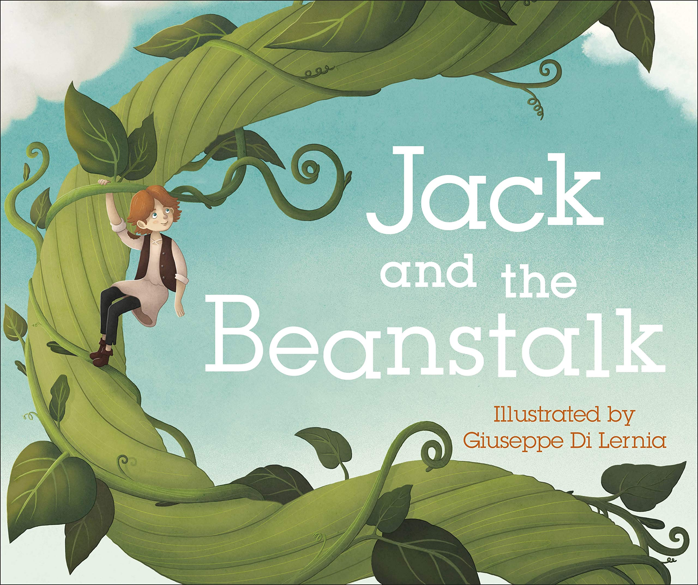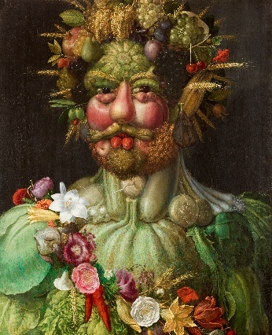

We will be exploring different fruit and vegetables all over the world. We will also be looking at how these are grown by farmers and sold to the markets. We will be identifying seasonal weather patterns. We will be planting our beans and observing how plants grow and creating artwork in the style of Giuseppe Arcimboldo.

**PSHE:** **Relationships**

In this topic, the children will recognise and learn about the qualities that make a good friend. They will learn about creating good relationships with others and how to seek help if they are unhappy.



International Primary Curriculum (IPC)

Over the next 7 weeks we will be following a unit of work on a theme that focuses on “Active Planet – Volcanoes and Earthquakes”. During this unit we will be focusing on **History and Geography.**

In History, we’ll be:

* Learning about the main characteristics of people and cultures that existed during the Stone Age, Bronze Age and Iron Age
* Finding

In Art, we’ll be:

• Creating our own prehistoric cave paintings

• Making and decorating pottery, based on one of the periods we have explored

In Technology we’ll be:

• Exploring the types of foods that the ﬁrst farmers would have grown

• Updating dishes that early settlers may have eaten

In IPC, we’ll be:

• Finding out how we can work together to learn new skills and achieve our goals

**Music**

The class will be singing songs with Mr Daggett on Wednesdays. They will also learn to play the African drums.

**Physical Education**

Our unit will be Send & Return. P.E will take place every Mondays and Fridays. Please remember to send in your child’s PE kit. (T-shirt, joggers, trainers)

**Cooking and Nutrition** **(CaN)** – Mondays!

We will be learning about herbs and comparing fresh and dried ones. We will be using our chopping skills to make a herb salad and planting our own herbs (cress).

**Computing:**

Our unit will be Animated Story Books!

We will be creating our own stories with moving picture on 2Create.

**SCIENCE**

***Unit:*** On Safari

We will be identifying and naming a variety of common invertebrates and those that are carnivores, herbivores and omnivores. We will be describing and comparing the structure of a variety of common invertebrates.

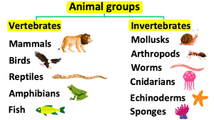

**Partnership with Parents**

**Maths**: Please help your child to complete maths homework on **Sumdog**. You should have your child’s log in details.

**Reading**. Children are expected to read every night for at least 20 minutes. Don’t forget to write a comment in your child’s Reading Record book when you have read with them. Books will be changed on Fridays. We would like all bookbags to be in school every day. Thank you!

**Homework:** Homework will be set on **Sumdog** every week. It is expected to be completed by all the children. **Times Table Rock stars** should be accessed by children to learn the 2,5,10 times tables only. Please support your child to practice them 4-5 times a week. They will also have many activities to do on Purple Mash. Any problems? Please let us know! We will also continue to send out weekly spellings for the children to practise.