**Half-Termly Curriculum Overview for Year 1 Spring 1 2024 January / February**

**Ms Abrahams, Ms Sharena, Mr Hussain & Ms Brenda**

**English**

In literacy we will be focussing on Stories from other cultures. We will be exploring the story ‘Nimesh the Adventurer’ and ‘Thank You Omu’. The children will learn about what makes a good adventure story and will create their own adventure stories and recipes inspired by Omu.

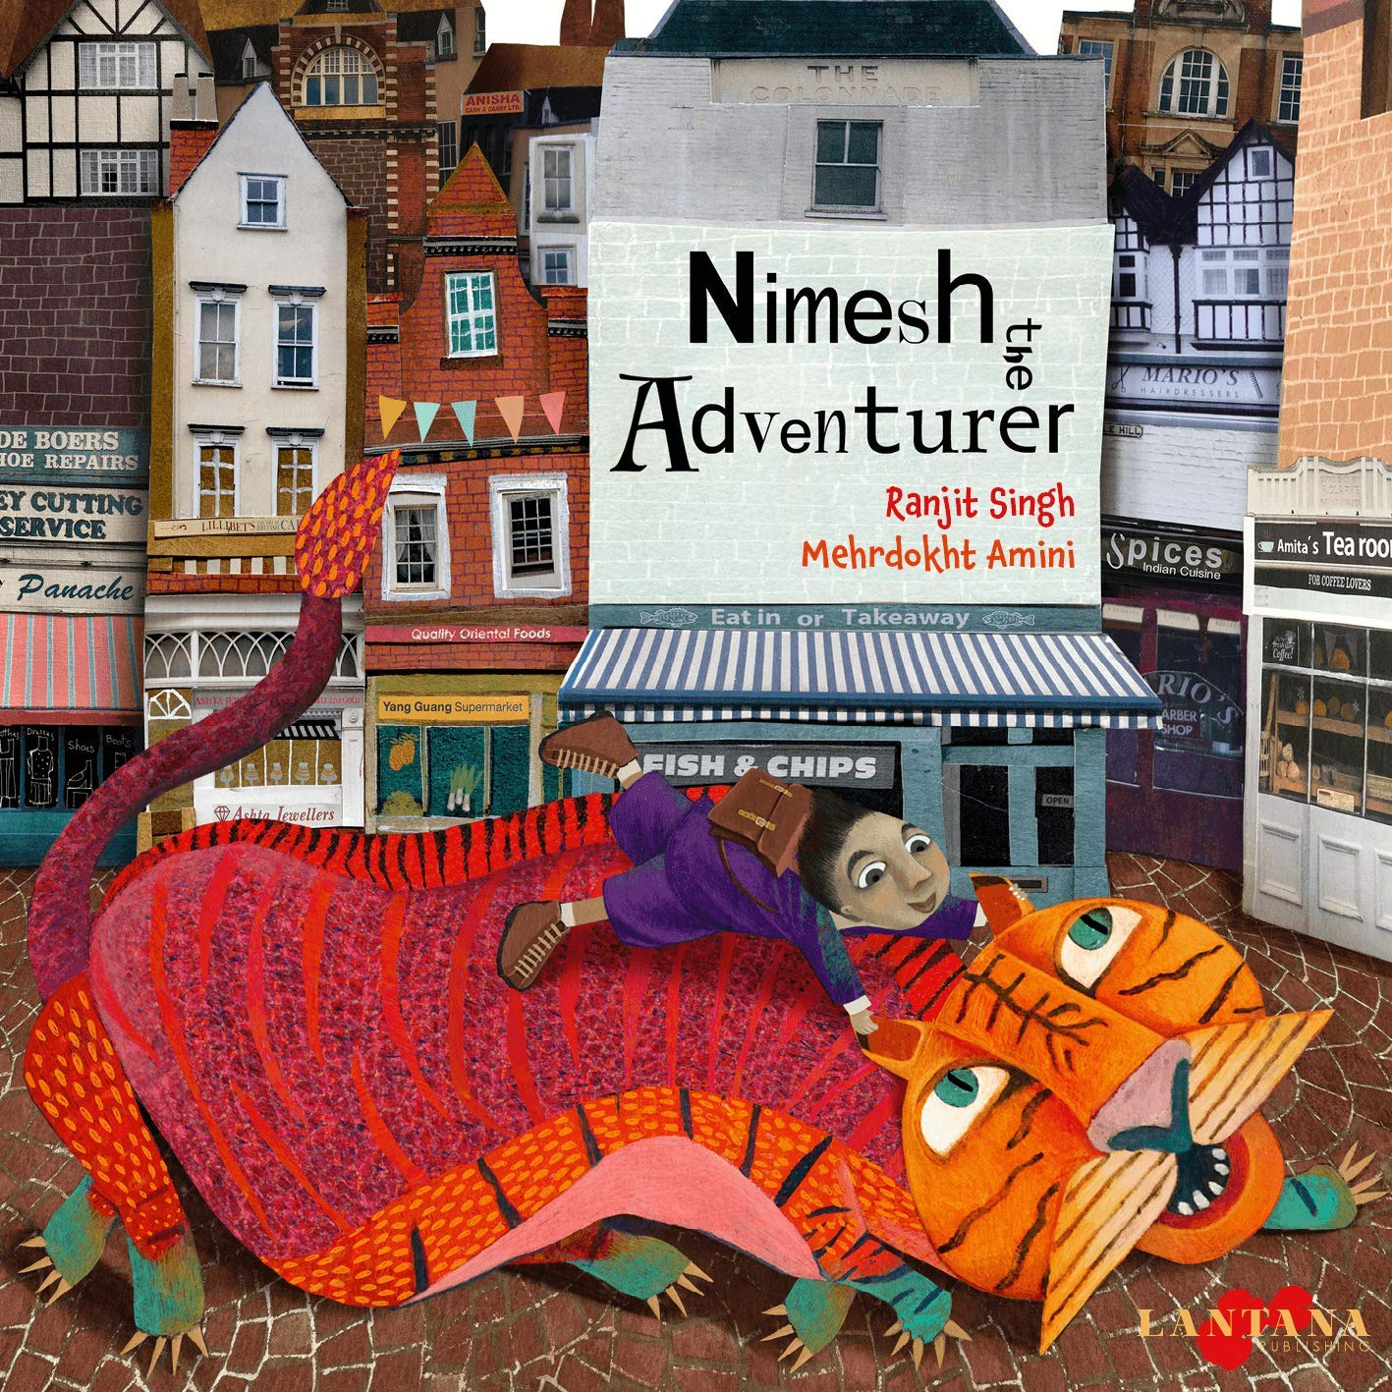 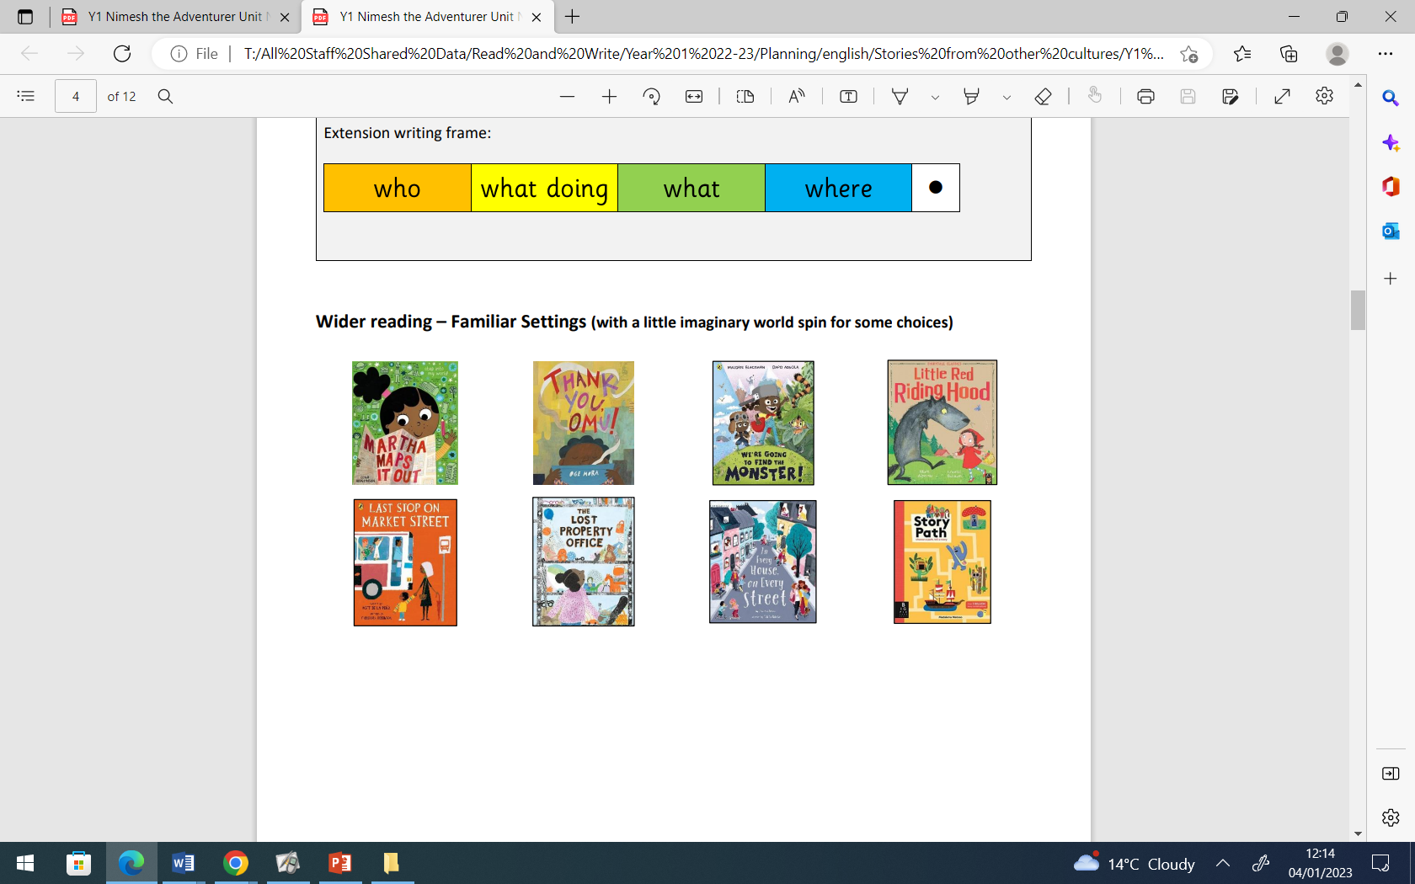

.

**Maths**

We will be looking at Place Value. They will also use mathematical language to solve addition and subtraction problems. They will learn to count forwards and backwards from a given number to 100 and beyond and count in steps of 2,5,10.

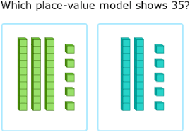

**Topic- Our School**

The children will be learning about Sonia Boyce.

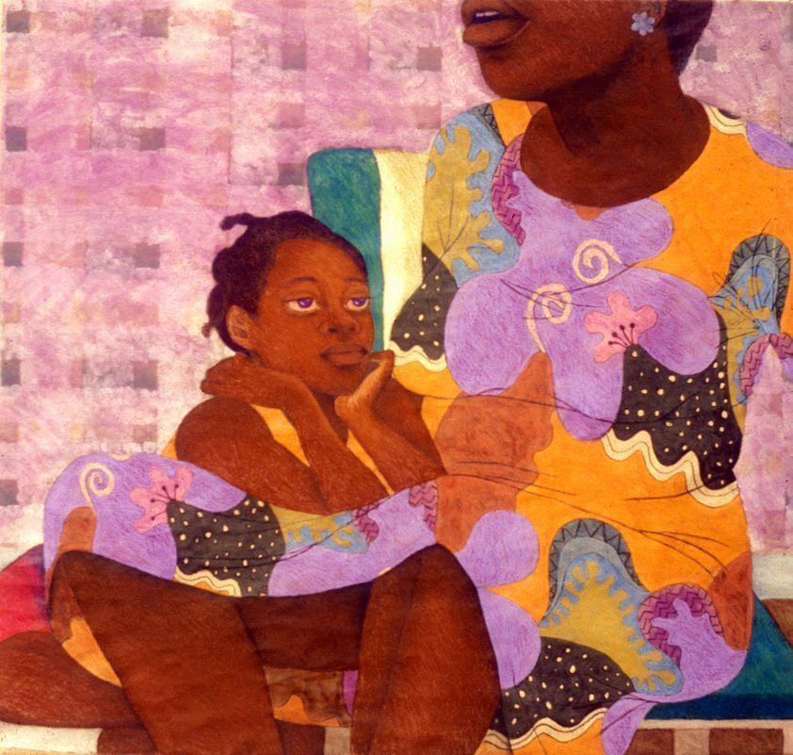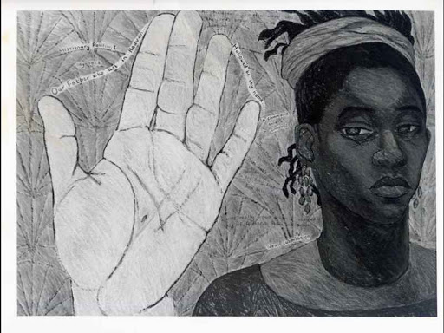

The children will use a range of materials creatively to design and make artwork inspired by Sonia Boyce. They will explore pattern, texture, line, space and shape.

They will learn about her life and what makes her artwork special.

**PSHE:** **Dreams and Goals**

The children will be learning about setting goals.

Children will be able to:

Set a goal and work out how to achieve it

How to work well with a partner/small groups to achieve their goals

Tackle a new challenge and understand this might stretch my learning

**Religious Education**

We will be focussing on Incarnation- Christianity

Key question:

Was it always easy for Jesus to show friendship?

The children will learn about how to be a good friend and explore friendships.

Key Question: What gift would I have given to Jesus if he had been born in my town and not in Bethlehem? They will reflect on the Christmas story and why Jesus is important to Christians.

International Primary Curriculum (IPC)

Over the next 7 weeks we will be following a unit of work on a theme that focuses on “Active Planet – Volcanoes and Earthquakes”. During this unit we will be focusing on **History and Geography.**

In History, we’ll be:

* Learning about the main characteristics of people and cultures that existed during the Stone Age, Bronze Age and Iron Age
* Finding

In Art, we’ll be:

• Creating our own prehistoric cave paintings

• Making and decorating pottery, based on one of the periods we have explored

In Technology we’ll be:

• Exploring the types of foods that the ﬁrst farmers would have grown

• Updating dishes that early settlers may have eaten

In IPC, we’ll be:

• Finding out how we can work together to learn new skills and achieve our goals

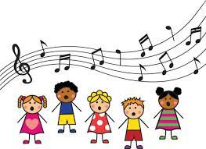**Music**

The class will be singing songs with Mr Daggett on Wednesdays. They will also learn to play the African drums.

**Physical Education – Gymnastics**

Our PE day will be every Monday. Please ensure that your child has a PE Kit, (white t-shirt, jog bottoms or leggings). Your child will be able to take their PE kit home at the end of every half term.

**Computing:** Lego Builders

We will be learning to follow and create simple instructions on the computer. They will explore algorithm -a step-by-step set of instructions used to solve a problem or achieve an objective.

**Cooking and Nutrition** **(CaN)** – Mondays!

We will be cooking what is in season and rustling up dishes in addition to challenging ourselves to use up store cupboard staples.

The children will be learning cutting, peeling, mashing and learning the importance of food hygiene.

**Science – Polar Adventures**

In science, we will be learning to name animals that are birds, fish and mammals. To name common animals that are carnivores, herbivores and omnivores. To describe and compare different common animals. They will identify and classify different materials and animals. The children will ask questions and answer them in different ways, observing ice activities closely. They will perform simple tests to test their ideas.



**Partnership with Parents**

**Maths**: Please help your child to complete maths homework on **Sumdog**. We have sent home the children’s log in details.

**Reading**. Children are expected to read every night for at least 15 minutes. Please write a comment in your child’s Reading Record Book when you have read with them. Books will be changed on Fridays. We would like all bookbags to be in school every day. Thank you!

**Homework:** Homework will be set on **Sumdog** every week. It is expected to be completed by all the children. **Times Table Rock stars** should be accessed by children to learn the 2,5,10 times tables only. Please support your child to practice them 4-5 times a week. Any problems? Please let us know! We will also be sending out weekly spellings for the children to practise.