**Half-Termly Curriculum Overview for Year 1 Spring 2 2023 February/March**

**Ms Abrahams,Ms Sharena, Mr Hussain & Mr Muhammad**

**English**

**Literacy**

We will be exploring books by Julia Donaldson and write about a Julia Donaldson book. Children will be able understand characters by talking about what a character looks like, how the character behaves and reasons for the character’s feelings or actions. They will write a complete story using a shared story plan and making use of features from reading to create our own story.

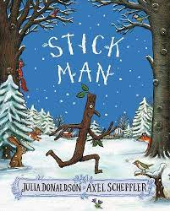 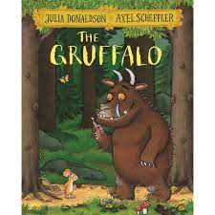

.

**Maths**

Our unit will be Place value (within 50) We will be counting forwards and backwards within 50 and find one more and one less than a given number. They will order numbers and learn to use number tracks to count, focussing on counting in 10s, 2s and 5s.

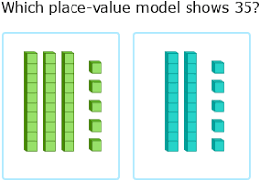

**Religious Education-**

Palm Sunday

Key question:

Why was Jesus welcomed as a king or celebrity on Palm Sunday?

We will be talking about special people in our lives.

Key Question: What gift would I have given to Jesus if he had been born in my town and not in Bethlehem? They will reflect on the Christmas story and why Jesus is important to Christians.

**Topic**

The children will be learning about **Ibn Battuta**

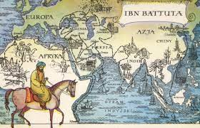

We will be learning about Ibn Battuta, who was one of the greatest explorers. We will be learning about who he was and his travels from Africa to Asia. We will be asking lots of questions to find out more about this great explorer.

**PSHE:** **Healthy me**

In this topic, children will be able to talk about making healthy choices. They will be discussing how to keep themselves clean, as well as understand how germs can cause diseases and illnesses.

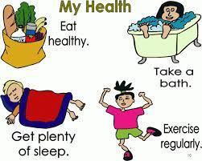

International Primary Curriculum (IPC)

Over the next 7 weeks we will be following a unit of work on a theme that focuses on “Active Planet – Volcanoes and Earthquakes”. During this unit we will be focusing on **History and Geography.**

In History, we’ll be:

* Learning about the main characteristics of people and cultures that existed during the Stone Age, Bronze Age and Iron Age
* Finding

In Art, we’ll be:

• Creating our own prehistoric cave paintings

• Making and decorating pottery, based on one of the periods we have explored

In Technology we’ll be:

• Exploring the types of foods that the ﬁrst farmers would have grown

• Updating dishes that early settlers may have eaten

In IPC, we’ll be:

• Finding out how we can work together to learn new skills and achieve our goals

**Music**

The class will be singing songs with Mr Daggett on Wednesdays. They will also learn to play the African drums.

**Physical Education**

Our unit will be Hit, Catch, Run! P.E will take place every Mondays and Tuesdays. Please remember to send in your child’s PE kit. (T-shirt, joggers, trainers)

**Computing:**

Our unit will be Maze Explorers!

We will be using the direction keys to complete games/ challenges successfully.

**Cooking and Nutrition** **(CaN)** – Mondays!

It’s Pancake season! Children will be making different varieties of pancakes with healthy tantilising toppings.

**SCIENCE**

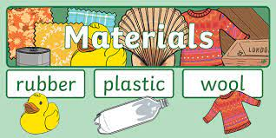

***Unit: Treasure Island***

In science we are learning all about Treasure Island. We will be able to;

Describe what fish are like compared to humans and other animals

Know why we need shelter in a desert island to protect ourselves.

Learn about some properties of materials and find suitable ones to make a shelter.

**Partnership with Parents**

**Maths**: Please help your child to complete maths homework on **Sumdog**. You should have your child’s log in details.

**Reading**. Children are expected to read every night for at least 20 minutes. Please write a comment in your child’s Reading Record book when you have read with them. Books will be changed on Fridays. We would like all bookbags to be in school every day. Thank you!

**Homework:** Homework will be set on **Sumdog** every week. It is expected to be completed by all the children. **Times Table Rock stars** should be accessed by children to learn the 2,5,10 times tables only. Please support your child to practice them 4-5 times a week. Any problems? Please let us know! We will also continue to send out weekly spellings for the children to practise.