**Half-Termly Curriculum Overview for Year 2**

**Ms Safia, Mrs Zainab, Mrs Sharena & Mr Hussain**

**Autumn Term 2**

**November/December 2023**

**English**

In literacy we will be reading fables. We will then plan and create our own fable.

We will be writing short stories and focusing on building WMG (what makes good) sentences. We will all be learning about sentence structure, using adjectives, adverbs and well-chosen verbs. Alongside this, we will be using conjunctions to extend our sentences and add detail.

Eg.

Before long, the **little** country mouse **scuttled quickly** to the **bustling** city **because** she was excited for an adventure. **After that,** she **gazed** at the **tall** buildings **until** she began to get hungry.

**Maths**

We will begin our term by continuing to learn different strategies for addition and subtraction. We will be adding and subtracting numbers up to 100, with and without regrouping.

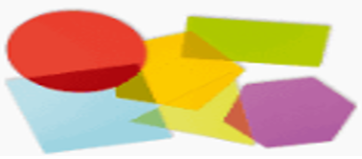

In the final weeks of term, we will move onto our geometry unit, where we will be studying 2d and 3d shapes. We will learn to identify and recognise the edges, faces and vertices of shapes, as well as look at various patterns and symmetry.

**Religious Education**

Theme: Christmas - Jesus as a symbol of light

**Key question for this enquiry:** How does the symbol of light help us to understand the meaning of Christmas for Christians?

**PSHE – Celebrating difference**

We will be learning to:

* Accept that everyone is different
* Include others when working and playing
* Know how to help someone if someone is being unkind
* Try to solve problems
* Try to use kind words
* Know how to give and receive compliments

**Cooking and Nutrition (CaN) –** THURSDAYS! We will be learning about health and safety in the kitchen and will be introduced to chef knives and how to chop safely.

**Topic – Geography – Asia**

**Key question: What can we learn about the continent of Asia?**

We will be using maps, atlas’ and globes to find and locate the oceans and continents of the world.

Using books and the internet, we will be researching countries that are in Asia and finding out information about them.

We will be looking at human and physical features of different countries and comparing them to the country we live in.

***Science***

We will be naming and recognising a variety of materials, and looking at their properties. We will then evaluate why different materials are used to make certain objects and recognise why they are suitable.

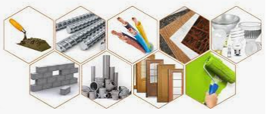

**Computing: Online safety and spreadsheets**

When learning about E-Safety, we are learning how to share work locally and the impact of sharing work on a global platform. We will explore how to use different communication tools, including email. We will be learning about the digital footprint that people leave when they use the internet and think critically about how trustworthy information on the internet is. We will also begin to use spreadsheets and how they are useful to store information.

**Physical Education – Hit, catch & run (PE kit needed Tuesday)**

In ‘hit, catch and run’ we will be learning the skills on how to throw, run, catch and hit with different equipment to build on our skills.

Parents- How Can You Help?

**Maths**: Please help your child to practise their times, 2, 3, 4, 5 and 10 tables. Purple mash is an excellent way to engage with your child.

**English**: Practising writing to improve letter formation, handwriting and sentence structure.

**Reading:** Books changed every Friday*Children are expected to read every night. We strongly encourage reading as many books as possible, as often as possible!

**HOMEWORK:** Homework is set every Friday on Purple Mash.

Music

The whole class will be singing with Mr Bruce on Wednesdays and doing drumming every Thursday.