**Half-Termly Curriculum Overview for Year 2 Spring 2023**

**Mrs Reader and Ms Safia**

**English**

In Literacy we will begin with non-fiction writing, where we will be writing a non-chronological report about dinosaurs!

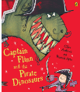

We will then create our own adventure story about a pirate dinosaur, inspired by the ‘Captain Flinn and the Pirate Dinosaur’ series. We will be looking closely at contracted forms and using different suffixes in our spellings.

**Maths** 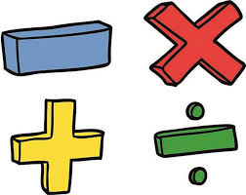

We will start the half term learning about division and multiplication. We are focussing on multiplication tables for groups of 2’s, 5’s and 10’s.

We will then move onto a measurement topic, starting with length and height. We will be using rulers to measure centimetres and metres. When completed, we will be learning about mass, capacity and temperature.

cm, m, kg, g, °C, ml, l

**Topic**

The children will continue to find out about Africa. They will explore human and physical features of different countries in the continent of Africa. After that, they will learn more about the culture of different countries, such as food, clothes and music. Children will be designing their own kente cloth patterns in art.

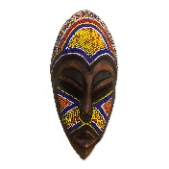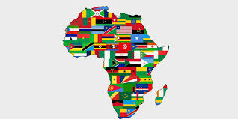 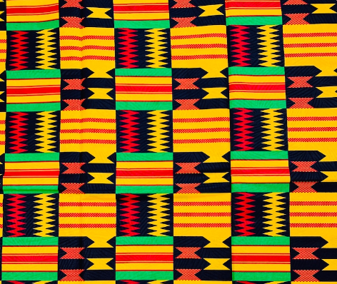

**PHSE**

Heathy Me

Outcomes: The children will be learning how to keep themselves safe, happy and healthy in all areas of their life.

**K**

**Religious Education**

We will be focussing on Christianity.

**The Key Question is**: How important is it to Christians that Jesus came back to life after the crucifixion?

International Primary Curriculum (IPC)

Over the next 7 weeks we will be following a unit of work on a theme that focuses on “Active Planet – Volcanoes and Earthquakes”. During this unit we will be focusing on **History and Geography.**

In History, we’ll be:

* Learning about the main characteristics of people and cultures that existed during the Stone Age, Bronze Age and Iron Age
* Finding

In Art, we’ll be:

• Creating our own prehistoric cave paintings

• Making and decorating pottery, based on one of the periods we have explored

In Technology we’ll be:

• Exploring the types of foods that the ﬁrst farmers would have grown

• Updating dishes that early settlers may have eaten

In IPC, we’ll be:

• Finding out how we can work together to learn new skills and achieve our goals

Music

The whole class will continue to work on the African drumming techniques as they learn new and challenging rhythms and song patterns. We also have singing lessons every Wednesday.

Physical Education – hit, catch, throw

Outcomes:. Children will be learning how to control and develop their hitting, throwing and catching skills, using a variety of sporting equipment. **Please bring your PE Kit on Tuesday and Wednesday.**

**Please bring your PE Kit on a Wednesday and swimming costume on Friday**

**Computing**

We will be completing our ‘Effective Searching’ unit. We will learn the correct terminology for searching and understand how to search purposely and safely on the Internet.

**Cooking and Nutrition** **(CaN)** – TUESDAYS!

We will be cooking what is in season and key skills will be to use a tin opener, heat ingredients in a saucepan, to safely boil. We will also be cooking tantilising African dishes!

**Partnership With Parents- SATs preparation**

**To help children to feel confident and supported in their learning by consolidating at home, here are some things that help a lot!**

**Maths**: Please help your child to practise their 2, 3, 4, 5 and 10 tables. Times tables Rockstars is helpful and fun!

**Reading:** Children are expected to read every night for at least 20 minutes. Please write a comment in your child’s Reading Record when you have read with them. Books will be changed on **Fridays.**

**Homework:** Homework will be set on Sumdog every week on a Friday, to be completed by the following Friday. Any problems? Let us know!

**Science – Move it!**

Children will be exploring different ways to make things move! We will be planning and conducting our own simple tests to make objects move in different ways, then record and discuss our findings. We will be looking into different objects that can be squashed, twisted, stretched and bent into different shapes.