**Half-Termly Curriculum Overview for Year 2 Spring 2023**

**Mrs Reader and Ms Safia**

**English**

In Literacy we will be reading a range of stories by significant authors like Anthony Browne. We will be writing short stories and focusing on building on what makes a good narrative. Year 2 will be focussing on time adverbials, verbs, adjectives, adverbs nouns and suffixes.

The children will also re-tell a class version and invent our own stories.

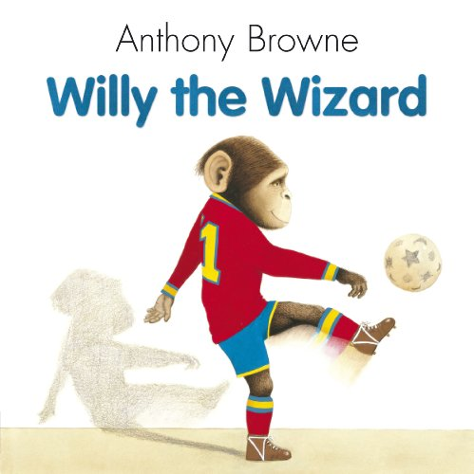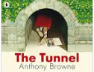

**Maths** 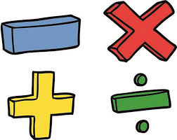

Multiplication/Division

We will start the term learning about money. We will be learning the value of coins and notes, then adding up the total amount. We will also find different ways to create a total amount using different coins. After money, we will begin division and multiplication. We will be making equal groups, adding them and making arrays. We are focussing on multiplication tables for groups of 2’s, 5’s and 10’s. The children will also be solving word problems related to multiplication.

**Topic**

The children will find out about Africa. They will learn about African Fables. They will be looking at questions like What is a fable? Which part of Africa did fables originate from?

They will be exploring pictures, photographs, artefacts and the internet to learn about Africa. They will use basic geographical vocabulary to find out about the key physical features, including mountains, seas, oceans, rivers and the human features, including: cities, towns and villages. The children will be making their own African masks and learning about different tribes.

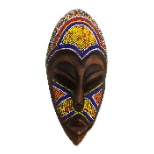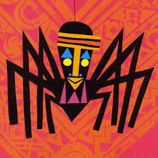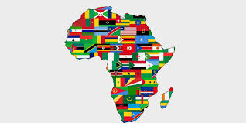

**PHSE**

Dreams and Goals

Outcomes: The children will be setting their own goals and think about how to achieve them. They will also look at what makes a good learner.

**K**

**Religious Education**

We will be focussing on Islam.

**The Key Question is**: Does praying at regular intervals help Muslims in everyday life?

International Primary Curriculum (IPC)

Over the next 7 weeks we will be following a unit of work on a theme that focuses on “Active Planet – Volcanoes and Earthquakes”. During this unit we will be focusing on **History and Geography.**

In History, we’ll be:

* Learning about the main characteristics of people and cultures that existed during the Stone Age, Bronze Age and Iron Age
* Finding

In Art, we’ll be:

• Creating our own prehistoric cave paintings

• Making and decorating pottery, based on one of the periods we have explored

In Technology we’ll be:

• Exploring the types of foods that the ﬁrst farmers would have grown

• Updating dishes that early settlers may have eaten

In IPC, we’ll be:

• Finding out how we can work together to learn new skills and achieve our goals

Music

The whole class will continue to work on the African drumming techniques as they learn new and challenging rhythms and song patterns. We also have singing lessons every Wednesday.

Physical Education – Games

Outcomes: Children will be able to learn the different. Skills required for games such as basketball and tag with our sports coach. **Please bring your PE Kit on Tuesday. Judo will be on Wednesdays.**

**Please bring your PE Kit on a Wednesday and swimming costume on Friday**

**Computing**

We will be Photographers. The children will be looking at what makes a good photo. The children will capture and edit photographs.

**Cooking and Nutrition** **(CaN)** – TUESDAYS!

We will be cooking what is in season and key skills will be to use a tin opener, heat ingredients in a saucepan, to safely boil. We will also be cooking tantilising African dishes!

**Partnership With Parents**

**Maths**: Please help your child to practise their 2, 3, 4, 5 and 10 tables. Times tables Rockstars is a fun way to engage children.

**Reading:** Children are expected to read every night for at least 20 minutes. Please write a comment in your child’s Reading Record when you have read with them. Books will be changed on **Fridays.**

**Homework:** Homework will be set on Sumdog every week on a Friday. It is expected to be completed by the following Friday. Any problems? Let us know!

**Science – Mini Worlds**

Children will be exploring and comparing the differences between things that are living and that are dead or have never been alive. To identify habitats and micro-habitats to which they are suited; to gain an understanding of a simple food-chain and sources of food.

