**Half-Termly Curriculum Overview for Year 2 Summer 1: 2024**

**Ms Safia, Mrs Zainab, Mrs Sharena & Mr Hussain**

**Maths: We will be looking at:**

We will begin this half term by at fractions. We will find ½, ¼ and 1/3 of different objects, as well as finding out the fractions of an amount. We will then learn strategies to find non-unit fractions. 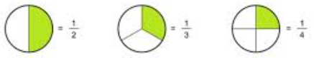

After that, we will be moving onto time, beginning with revising o’clock and half past. We then will learn quarter past and quarter to on an analogue clock. After that, we will find the time to the nearest 5 minutes. 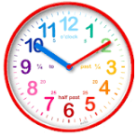

**English** 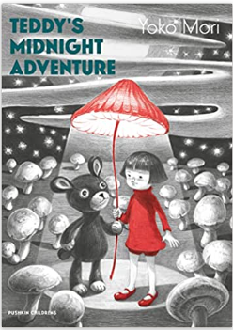

We will begin our term with the brilliant text ‘Teddy’s Midnight Adventure’ and looking carefully at language that the author uses. We will look at suffixes and prefixes that change different root words and explore sentences that we can make with them. We will then create our own fantasy stories of our own, making sure we include all of the necessary punctuation and grammar. After we have finished, we will be writing an explanation text based on ‘Man on the Moon’.

**Religious Education**

We will be focussing on Islam.

**Key Question:** [**How do the five pillars of Islam help a Muslim to show commitment to God-Allah**](https://ldbs.co.uk/wp-content/uploads/2024/03/YEAR-2-How-do-the-five-pillars-of-Islam-help-a-Muslim-to-show-commitment-to-God-Allah.pptx)**?**

**Topic: Geography: Our World**

**Key question: Where on Earth are we?**

We are learning about the part of the world that we live in – the United Kingdom! We will learn the countries and capital cities that are included in the UK, and locate them on a map or atlas. We will be looking closely at the city of London by conducting fieldwork in the local area, to enable us to design our own map. We will also be considering how to look after the world around us and what an impact that has!



**PHSE:** **Relationships**

**Key Question: Who is special to me?**

Outcomes: The children will look at positive ways to solve friendship problems when they occur, they will learn how to express their appreciation for the people in their special relationships and I recognise who can help them in their family, school and community.

**K**

International Primary Curriculum (IPC)

Over the next 7 weeks we will be following a unit of work on a theme that focuses on “Active Planet – Volcanoes and Earthquakes”. During this unit we will be focusing on **History and Geography.**

In History, we’ll be:

* Learning about the main characteristics of people and cultures that existed during the Stone Age, Bronze Age and Iron Age
* Finding

In Art, we’ll be:

• Creating our own prehistoric cave paintings

• Making and decorating pottery, based on one of the periods we have explored

In Technology we’ll be:

• Exploring the types of foods that the ﬁrst farmers would have grown

• Updating dishes that early settlers may have eaten

In IPC, we’ll be:

• Finding out how we can work together to learn new skills and achieve our goals

**Music**

The whole class will continue to work on the African drumming techniques as they learn new and challenging rhythms and song patterns. 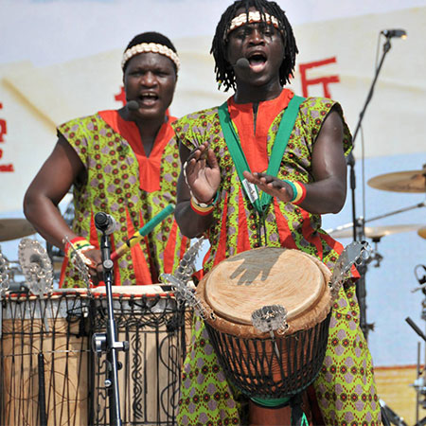

**Physical Education –Attack, defend,shoot**

Outcomes: Children will be able to learn the different. Skills required for games. **Please bring your PE Kit on Tuesday.**

**Please bring your PE Kit on a Wednesday and swimming costume on Friday**

**Computing**

We will be exploring 2paint on Purple Mash to create our own portraits inspired by famous artists including Picasso and Kandinsky.

**Cooking and Nutrition** **(CaN)** – THURSDAY!

We will be cooking what is in season and rustling up dishes in addition to, challenging ourselves to use up store cupboard staples.

**Partnership With Parents**

**Maths**: Please help your child to practise their 2, 3, 4, 5 and 10 tables. Times tables Rockstars is a fun way to engage children.

**Reading:** Books will be changed on Wednesday & Fridays. Children are expected to read every night for at least 20 minutes. Please write a comment in your child’s Reading Record book when you have read with them.

**Homework:** Homework will be set on PurpleMash every week on a Friday. It is expected to be completed by the following Friday. Any problems? Let us know!

**Science – ‘Young Gardners’**

Children will be learning about ‘Young Gardners’, naming plant parts, functions of plant parts and naming different plants e.g. vegetables, flowers. They’ll also be growing from seeds and bulbs, while looking at conditions for growth.

