**Half-Termly Curriculum Overview for Year 3 Summer 2 June/July 2023**

**Miss Ali & Miss Maya**

Maths – Time/Shape

Outcomes: In small steps children will be able to:

“Understand that there are different types of angles.

“Understand, measure and draw angles accurately.

“Understand that Roman numerals are still in use today.

“Understand the differences of the hour, minute and second hand.

“Learn to read the time accurately on s digital and analogue clocks.

“Learn about years, months and days.

English – Ottoline and the Yellow cat

To use conjunctions effectively in writing.

To have a problem and resolution in their writing.

To use correct punctuation

To re-read and edit work

Outcomes:

Children will be able to create an exciting detective story using the key features of the text type and be able to assess their writing.

We will be studying the book – Ottoline and the yellow cat by Marin Riddell

PHSE – Changing Me

Outcomes: Children will be able to:

* Understand that in animals and humans lots of changes happen between birth and growing up.
* They should be able to talk about how a baby changes from a baby to a child.
* Learn that babies grow in a females womb for around 9 months..

TOPIC

Over the next 7 weeks we will be following a unit of work on the Mexican artist Frida Kahlo. During this unit we will be focusing on **Art work.**

**We will:**

**- locate Mexico on a world map.**

**- find out about the life of Frida Kahlo.**

**- explore her paintings.**

**- draw our own self portrait in her style**

**- use similar techniques on our own portraits**

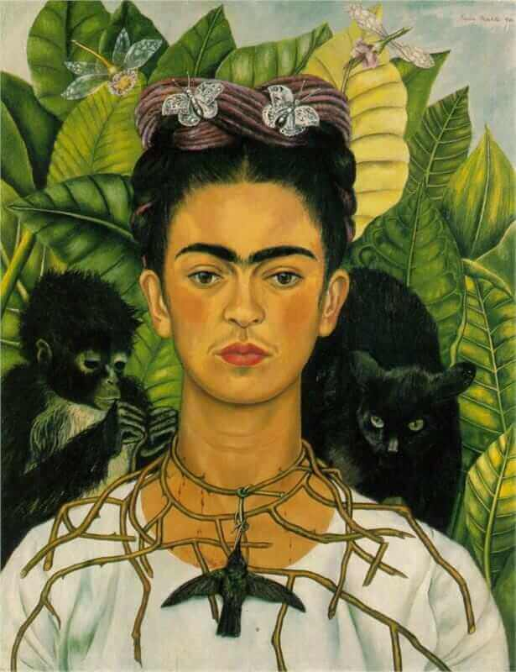

Religious Education - Sikhism

We will be exploring the key question: Do Sikhs think it’s important to share?

Outcomes: Children will be able to:

Understand the main beliefs of the Sikh religion.

Know the story of Guru Nanak

Find out how Sikhs live today

International Primary Curriculum (IPC)

Over the next 7 weeks we will be following a unit of work on a theme that focuses on “Active Planet – Volcanoes and Earthquakes”. During this unit we will be focusing on **History and Geography.**

In History, we’ll be:

* Learning about the main characteristics of people and cultures that existed during the Stone Age, Bronze Age and Iron Age
* Finding

In Art, we’ll be:

• Creating our own prehistoric cave paintings

• Making and decorating pottery, based on one of the periods we have explored

In Technology we’ll be:

• Exploring the types of foods that the ﬁrst farmers would have grown

• Updating dishes that early settlers may have eaten

In IPC, we’ll be:

• Finding out how we can work together to learn new skills and achieve our goals

French

We will be learning the story of Le Petit Chaperon Rouge (Little red riding hood) in French. This will help us learn about body parts.

Physical Education – Gymnastics

Outcomes: Children will be able to learn the different

Skills required for games such as basketball, tag etc. they will also learn how to work together in groups and pairs.

**PE kit every Monday and Friday**

**Please bring your PE Kit on a Wednesday and swimming costume on Friday**

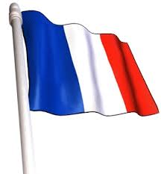

Computing

We will be learning about emails. How they work, how to write one and how to send it.

Music

The whole class will be doing singing with Mr Daggett every week. They will be learning how to read music as well as learn to sing a range of songs. Drumming will continue every Thursday

Science – We are Astronauts

We will be looking at how to become astronauts.

Outcome:

* To describe the appearance of the near and far side of the Moon..

To investigate model rocket to see what makes it work well.

To name some famous cosmonauts and astronauts and explain what they did?

I can design and build a model Moon Lander.

I

Use words like attract and repel

Partnership With Parents

Below are some ways that you can engage with your child’s learning.

Reading - Children are expected to read their school library book at home each night and bring it into school each day. Please read with your child and discuss what you read.

Maths – Tasks are set online through MY MATHS and children can practice timetable Rockstars

* Please help your child to recite and memorise the 4 times table as well as to revise 2, 5, 10.
* Any additional homework will be given out in due course.