**Half-Term Curriculum Overview for Year 4 Summer Term 1 April/May 2024**

**Ms Maya, Mrs. Grundy (Monday, Tuesday and Wednesday morning)**

**Literacy**

.

To identify the features of a myth

To create an original myth

To dramatise and role-play Egyptian myths

Outcomes: Children will be able to:

* create settings, mythical creatures and a plot
* use expanded noun phrases to extend their descriptive writing
* present their work to an audience

**Numeracy**

Children will learn how to:

- Compare numbers with the same number of decimal places up to two decimal places.

- Round decimals with one decimal place to the nearest whole number

- Recognise and write decimal equivalents to a quarter, half and three quarters.

- Find the effect of dividing a one or two digit number by 10 or 100, identifying the value of the digits in the answer as ones, tenths and hundredths.

- Estimate, compare and calculate different measures, including money in pounds and pence.

Temples, Tombs

International Primary Curriculum: Temples, Tombs and Treasures

**In History:**

Children will:

- Know about the main events, dates and

characteristics of Ancient Egypt

- Know about the lives of people in those periods

- Know about the main similarities and differences between Ancient Egypt and Ancient Sumer

- Be able to give some reasons for particular events and changes

**In Art:**

Children will:

- Know how Ancient Egyptian artists used forms, materials and processes to decorate their tombs, buildings and belongings

Ancient Egypt

**Topic: Ancient Egypt**

Children will:  
- Compare and contrast the lives of Ancient Egyptians   
with our modern lives  
- Learn about Ancient Egyptian religions, including the Egyptian Pantheon of Gods, burial rites including mummification and the building of the pyramids as well as Ancient Egyptian beliefs about the afterlife  
- Learn how the geography of the River Nile helped shaped their civilization through developments of technologies like irrigation  
- Learn about famous archaeologists such as Howard Carter and consider if their methods were ethical, including discussion on modern museum ethics

[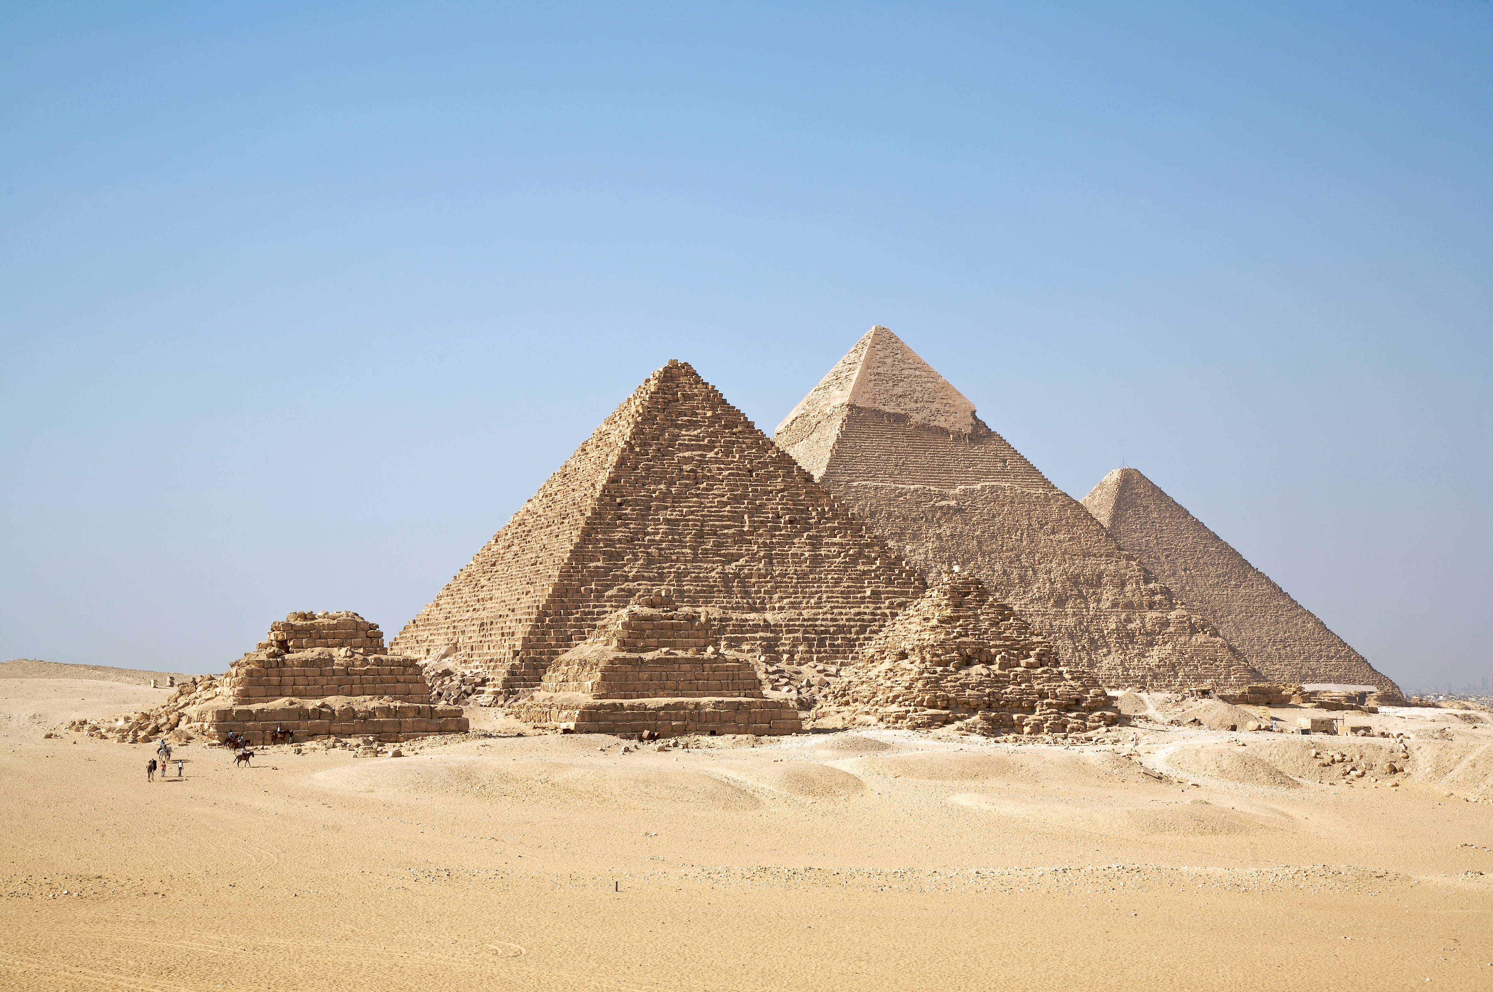](http://www.google.co.uk/url?sa=i&rct=j&q=egyptian+pyramids&source=images&cd=&cad=rja&uact=8&ved=0CAcQjRw&url=http://en.wikipedia.org/wiki/Egyptian_pyramids&ei=1-sTVZvOAYHDPcyigJgL&bvm=bv.89217033,d.ZGU&psig=AFQjCNHb4vBtLwy6h8W41F3i3A9Pn9T7Vg&ust=1427455317236435)

**RE: Hinduism**

Our focus question is ‘What does it mean to live as a Hindu?’ The children will explore Hinduism beliefs and practices. What it means to be born into a Hindu family. How the belief in karma and dharma affects a Hindu person’s actions.

**PHSE: Relationships**

Children will develop their understanding of the web of relationships they are part of and their roles and responsibilities within.

**PE: PE on Monday (double lesson)**

Children will continue to:

- develop team skills in games

- develop resilience during team games

- to understand that losing is an important part of team games.

**Children should bring in their kits on Monday.**

**French**

To recognise and say numbers 21-31.

Food & Drinks

**Computing**

To explore how font size and style can affect the impact of a text.

• To use a simulated scenario to produce a news report.

• To use a simulated scenario to write for a community campaign.

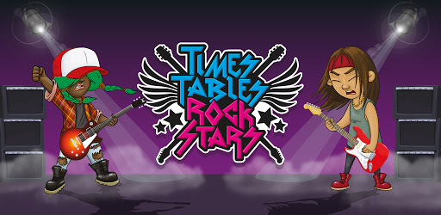

**Music**

Drumming on Thursdays. Singing with Mr. Bruce on Wednesdays

**Science - Power It Up!**

Children learn about electricity.

We will explore:

- Uses of electricity

- The importance of safety around electricity

- How to construct simple circuits and interpret diagrams

**Parents How Can You Help?**

Children should be practising with **Times Tables Rockstars** regularly.

**Reading:** Children are expected to read every night and bring their Guided Reading books in their yellow book bag to school every day.