**Half-Term Curriculum Overview for Year 4 Summer Term 2 June/July 2023**

**Ms Hendy, Ms Liz Mrs.Grundy**

**Literacy**

To identify the features of issues and dilemmas.

To create an original discussion

Outcomes:

Children will be able to:

* discuss the impact of choice and dangers.
* discuss feelings and moods of stories
* write an original piece debating an issue

**Numeracy**

Children will be able to:

* Use co-ordinates.
* Interpret bar charts, pictograms and graphs.
* Calculate perimeters and areas of shapes.
* Recognise angles as a property of shape or a description of a turn.

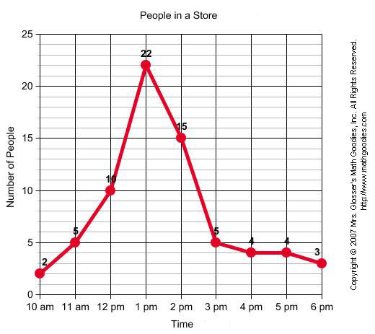

**Topic: Ancient Rome**

Children will:

- Know about the main events, dates and characteristics of Ancient Rome

- Know about the lives of people in those periods  
- Understand the relationship between the gods of Ancient Greece and Ancient Rome

- Know about the Roman invasion of Celtic Britain

- Be able to give some reasons for particular events and changes  
- Learn about Roman mosaics and try making one of their own

**Religious Education: Christianity**

Key Question: **Do people need to go to church to show they are Christians?**

Children will:

- talk about some of the things that are important to Christians during worship and explain their symbolism.

- describe some of the ways Christians use churches to worship/celebrate Holy Communion or participate in baptism.

- give a range of ways that Christians can show their beliefs.

**PHSE: Changing Me**

Children will explore changes that occur during puberty, at different times for different people.   
Children will be taught strategies for managing change and anxieties about change.

**Computing:**

**We are Animators!**

The children will work collaboratively to plan, make and edit simple animations in a traditional 2D style to tell short stories with their own characters.

**French**

Little Red Riding Hood

**PE on Monday,Tuesday & Thursday**

Basketball

**Children will**

**- practise hand to eye co-ordination**

**- learn different techniques for passing**

**- work as a team**

**Science: I’m Forever Blowing Bubbles**

After finishing our unit on electricity, we will look at bubbles! We all enjoy blowing bubble, but are they always spherical? Can we make square bubbles? What about different coloured bubbles or very tiny ones? We will also look at places we see bubbles other than when blowing them through soap mixture,

such as in food.

[](https://www.google.co.uk/url?sa=i&rct=j&q=&esrc=s&source=images&cd=&cad=rja&uact=8&ved=2ahUKEwj7rcSbrL_bAhUBWRQKHW99D3gQjRx6BAgBEAU&url=https://www.peakprosperity.com/blog/87966/understanding-asset-bubbles-crash-course-chapter-17&psig=AOvVaw0RKPSiKcVPdHMztcTnbXTa&ust=1528385067442970)

**Music**

Drumming with Michael on Thursdays. Singing with Mr. Daggett on Wednesdays

**Parents How Can You Help?**

Children should be practising with **Times Tables Rockstars** regularly.

**Reading:** Children are expected to read every night and bring their Guided Reading books in their yellow book bag to school every day.