**Half-Termly Curriculum Overview for Year 1 Autumn Term 2 November/December 2019**

**Miss Ali Miss Saida Miss Brenda**

Maths

Represent and use number bonds and relate subtraction facts within 10.

Add and subtract 1-digit numbers to 10.

Start to solve one step problems that involve addition

and subtraction using pictorial representations.

Outcomes: Children will be able to:

Say how many more needed to make ten.

Explore different strategies to add and subtract.

See the relation between adding and subtracting.

Use part whole models/bar models to represent number sentences.

English

To explore traditional tales.

To be able to use full stops and capital letters correctly.

To start to use and in their writing.

Outcomes: Children will be able to:

Use adjectives to describe a character.

Understand what are nouns and verbs.

Retell stories with similar experiences to themselves.

Create an exciting story using the key features of the text type

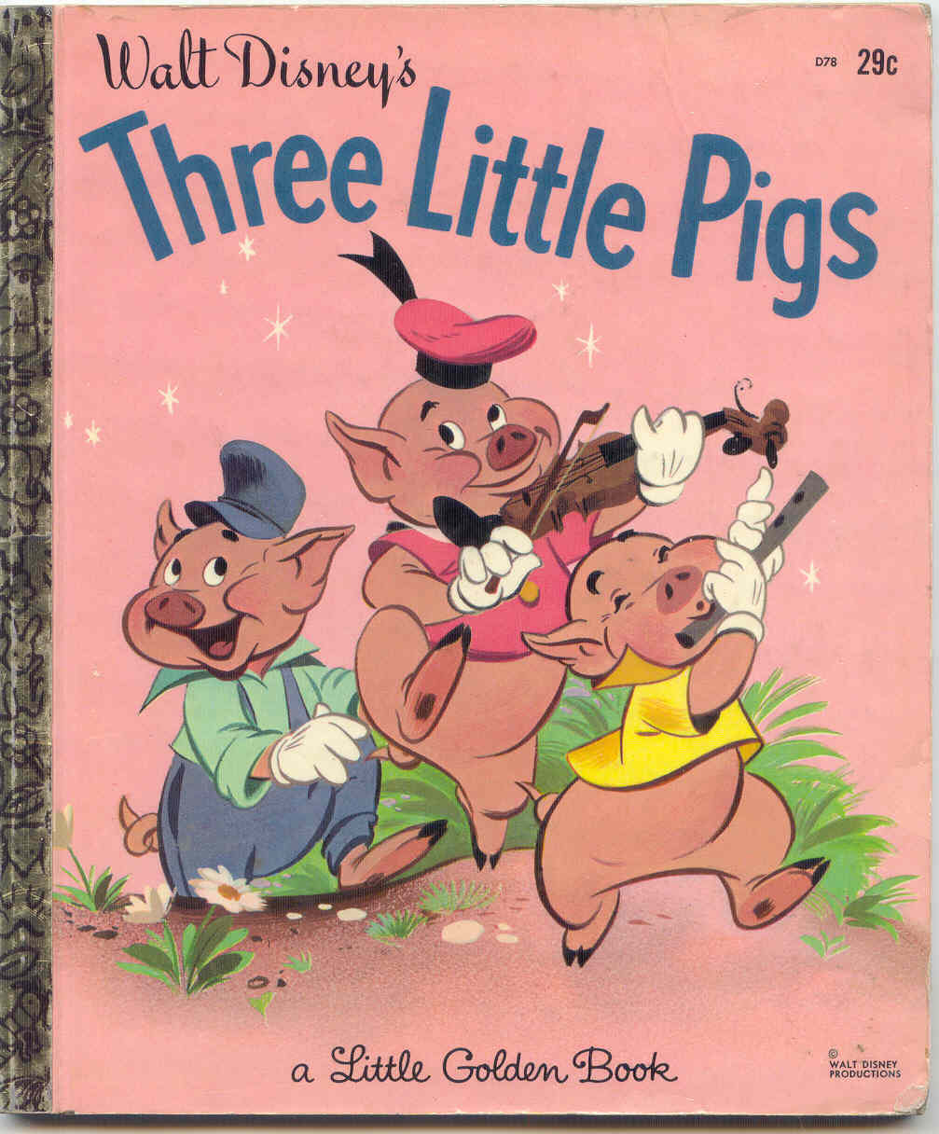

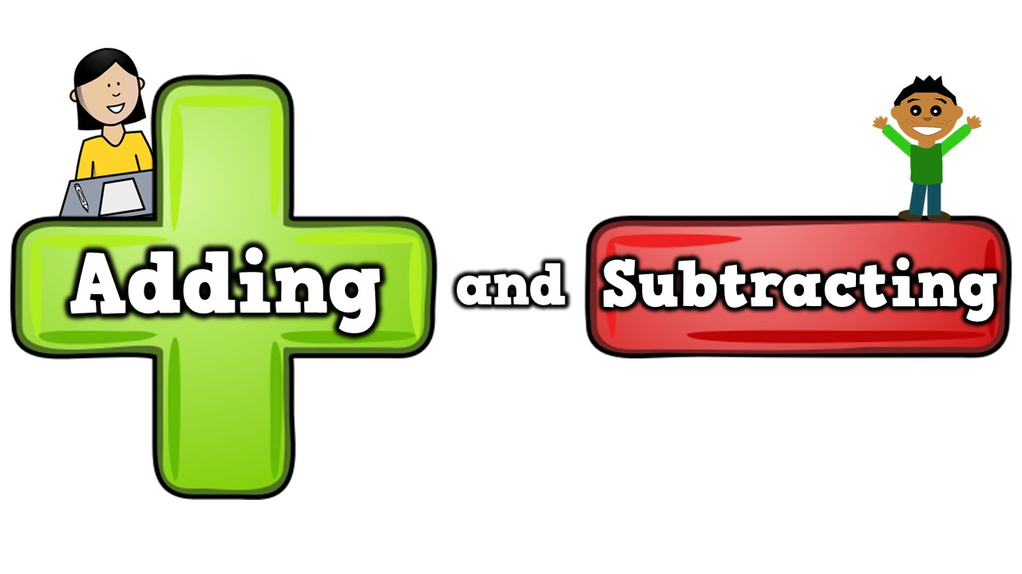

International Primary Curriculum (IPC)

Over the next 7 weeks we will be following a unit of work on a theme that focuses on “Toys from the Past”. During this unit we will be focusing on **History, Science and Design and Technology.**

In History, we’ll be:

• Exploring how toys have changed over the years..

• Use the correct vocabulary to describe old toys.

• Find answers to questions by using past sources (photos, videos etc).

In Science, we’ll be:

• Exploring how toys move.

• Discuss what materials old toys are made from.

In D&T, we’ll be:

• Make a moving toy.

International Primary Curriculum (IPC)

Over the next 7 weeks we will be following a unit of work on a theme that focuses on “Toys from the past”. During this unit we will be focusing on **History, Science and D&T.**

In History, we’ll be:

• Exploring how toys have changed over the years.

• Use the correct vocabulary to describe toys.

• Find answers to questions by using past sources (photos, videos etc).

In Science, we’ll be:

• looking at the types of materials old toys are made from.

• how toys move

In D&T, we’ll be:

• making a moving toy.

• Compare different celebrations.

PHSE – Celebrating Differences

To know that I am special and unique

Outcomes: Children will be able to:

Think about how they are similar to their friends. Know that it is okay to be different to their friends.

Religious Education

To explore the Christmas Story and explore the question

‘What gift would I have given Jesus if he had been born in my town and not in Bethlehem?’

Outcomes: Children will be able to:

Recall some parts of the Christmas Story.

Understand why Jesus is special to Christians.

Physical Education –Games

Outcomes: Children will be able to learn the different

Skills required for games such as basketball, tag etc. They will also learn how to work together in groups and pairs.

**PE kit every Mondays. (T-shirt, shorts or joggers, trainers or plimsolls.**

SCIENCE Let’s Celebrate – Light and dark

To observe things using simple equipment.

To identify and sort different things.

To collect and record data to help answer questions.

We will be looking at:

Light sources

Shadow

Exploring the differences between light and dark.

Computing: We are TV Chefs

We will be looking at writing simple recipes on the laptops.

Use a camera to record.

Parents How Can You Help?

**Maths**: Children need to learn how to count to and back from 50 from any given number. Practice 2, 10 and 5 times table.

**Reading:** Children will receive reading book 3 times a week. Books will be changed Monday, Wednesday and Friday. Please feel free to write a comment in record book.

**Homework**: My Maths homework will be set online as well as Timetable rock stars.

Music

The whole class will be learning to play

the drum this year.