**Half-Termly Curriculum Overview for Year 1 Spring term 1 January/February 2020**

**Miss Ali Miss Saida Miss Brenda**

English

To explore stories from other cultures.

To be able to use full stops and capital letters correctly.

To start to use their own ideas to write a short story.

Outcomes: Children will be able to:

Use adjectives to describe a character.

Understand what are nouns and verbs.

Retell stories with their own ideas.

Write a story with a beginning. Middle and an end.

Maths

Represent and use number bonds and relate subtraction facts within 20.

Add and subtract one and two-digit numbers to 20.

Start to solve one step problems that involve addition

and subtraction using pictorial representations.

Outcomes: Children will be able to:

Say how many more needed to make twenty.

Explore different strategies to add and subtract.

See the relation between adding and subtracting.

Use part whole models/bar models to represent number sentences.

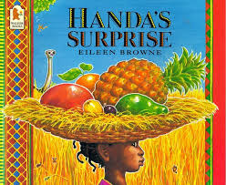

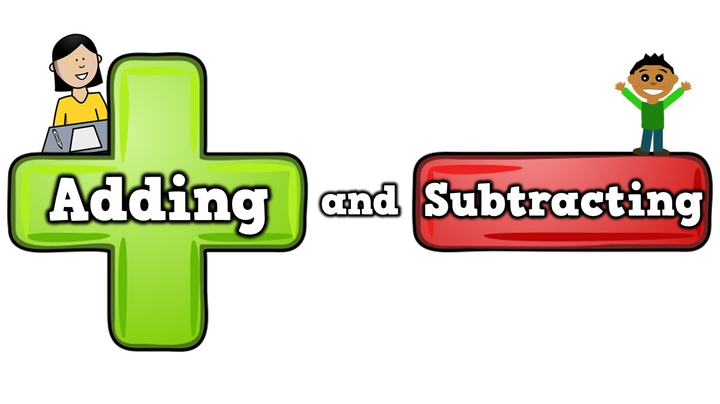

International Primary Curriculum (IPC)

Over the next 7 weeks we will be following a unit of work on a theme that focuses on “Toys from the Past”. During this unit we will be focusing on **History, Science and Design and Technology.**

In History, we’ll be:

• Exploring how toys have changed over the years..

• Use the correct vocabulary to describe old toys.

• Find answers to questions by using past sources (photos, videos etc).

In Science, we’ll be:

• Exploring how toys move.

• Discuss what materials old toys are made from.

In D&T, we’ll be:

• Make a moving toy.

International Primary Curriculum (IPC)

Over the next 6 weeks we will be following a unit of work on a theme that focuses on “Significant person of the past”. During this unit we will be focusing on **History and Art.** Our famous person is the painter Vincent Van Gogh.

In History, we’ll be:

• looking at Van Gogh’s life and how his life shaped what he painted.

• explore how the past is represented through books and stories.

In Art, we’ll be:

• recreating Van Gogh’s paintings in class using a variety of materials.

• learn how to mix colours.

PHSE – Dreams and Goals

To know that I have goals and dreams.

Outcomes: Children will be able to:

Think about their long and short term goals. Begin to work on how to achieve their goals and the feelings involved.

Religious Education

To explore Jesus’ life and explore the question

‘Was it always easy for Jesus to show friendship?’

Outcomes: Children will be able to:

Recall some stories about Jesus and how he was a friend to all.

Understand why Jesus is special to Christians.

Physical Education –Games

Outcomes: Children will be able to learn the different

Skills required for games such as basketball, tag etc. They will also learn how to work together in groups and pairs.

**PE kit every Mondays and Fridays. (T-shirt, shorts or joggers, trainers or plimsolls.**

SCIENCE Polar Adventurers

To observe things using simple equipment.

To identify and sort different things.

To collect and record data to help answer questions.

We will be looking at:

Different types of materials

Which material is best for which purpose?

Exploring the differences between hot and cold

Computing: We are Painters

We will be looking at using the paint programme on the computer. We will be making an eBook.

Parents How Can You Help?

**Maths**: Children need to learn how to count to and back from 100 from any given number. Practice 2, 10 and 5 times table.

**Reading:** Children will receive reading book 3 times a week. Books will be changed Monday, Wednesday and Friday. Please feel free to write a comment in record book.

**Homework**: My Maths homework will be set online as well as Timetable rock stars.

Music

The whole class will be learning to play

the drum this year.