**Half-Termly Curriculum Overview for Year 2 Summer Term 2 June/July 2020**

**Mr Thompson and Mr Hussain**

Maths

**Mass, Capacity and Temperature**

* Estimate and measure length/height in any direction (m/cm); mass (kg/g); temperature (°C); capacity (litres/ml) to the nearest appropriate unit,
* Use rulers, scales and thermometers
* Compare and order lengths, mass, volume/capacity and record the results using >, < and =

**Time**

* Tell and write the time to five minutes, including quarter past/to the hour
* draw the hands on a clock face to show these times.
* Know the number of minutes in an hour and the number of hours in a day.
* Compare and sequence intervals of time.

How important is colour?

Explore different types of art and think about:

How does colour affect you?

What happens when you mix colour?

What happens when there is no colour?

Then explore different artists through history and the impact they have had.

International Primary Curriculum (IPC)

Over the next 7 weeks we will be following a unit of work on a theme that focuses on “Scavengers and Settlers”. During this unit we will be focusing on **History, Art, Technology and International.**

In History

Children will:

Be able, with help, to gather information from simple texts

Know about the basic conditions needed for living things to survive

Know about the differences between living

things and things that have never been alive

Know that living things grow and reproduce

Know that the features of the schoolb environment affect the types of livingnthings found there

Be able to sort living things into simple groups

Be able to recognise living things in the school environment

Understand that different locations support different living things

English

**Traditional tales with a twist – Yours truly goldilocks**

Exploring traditional tales and looking at

ways to change them e.g swapping characters.

Focus on descriptions of characters, settings

and dialogue.

**Non-chronological reports – Man on the moon**

Using this text and others to learn more about

space and in particular the moon. Then writing

their own reports. Focus on present tense and

third person.

TALK!

We encourage the children in our class to discus their ideas. We hope they come home from school each day with plenty of ideas to share with you.

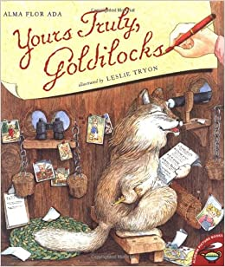

PHSE – Changing Me

* Life cycles
* Differences from a baby to now
* Respecting differences
* Looking ahead to growing older.

Religious Education

Theme – Hajj

Key Question:

Does completing Hajj make a person a better Muslim?

**Religion: Islam**

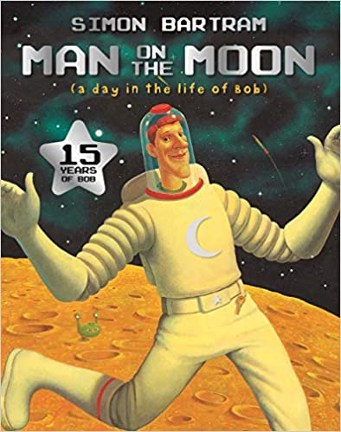

Physical Education – Judo

Children will take part in the ‘Daily Mile’.

This involves 15 minutes of physical activity daily.

Children will take part in gymnastic lessons.

**Please bring your PE Kit on Monday.**

Cooking and Nutrition – TUESDAYS!

We will be learning about health and safety in the kitchen and will be introduced to chef knives and how to chop safely.



Music

The whole class will be continuing to learn drumming.

Computing: We are zoologists

* This unit is all about gathering, recording and displaying data. This is done though exploring their local environment and finding out about mini-beasts.

Science – Little Master chefs

Making good food choices

Knowing how different foods help to keep the body healthy. Hygiene when cooking.

Changes in cooking.

Best materials for particular uses, e.g. storing food. Changing dough, squashing, bending, twisting, stretching.

How Can You Help?

**Maths**: Please help your child to practise their times, 2, 3, 4, 5 and 10 tables. The website below has useful resources for this: <https://www.topmarks.co.uk/maths-games/hit-the-button>

Your child also has logins for Times Table Rockstars and My Maths

**Reading:** Children are expected to read every night. Supplementary reading is always advised.

**PE kit every Monday, home on Friday**

**Maths homework is available each Friday on** [https://app.mymaths.co.uk](https://app.mymaths.co.uk/)