**Half-Termly Curriculum Overview for Year 3 Autumn Term 2 October-December 2019**

**Mr Cush-Etter and Ms. Grundy**

Literacy

We will be exploring fiction stories by Dick-King Smith this term – particularly focusing on the books ‘Horse Pie’ and ‘Mouse Family Robinson’!

Outcomes: Children will be able to:

Create their own setting and characters for their own fiction stories.

Write a clearly structured story with a problem and resolution.

Write in the third person – choosing imaginative vocabulary to make their stories interesting.

Maths

To add and subtract numbers – including 3-digit numbers and ones, tens or hundreds.

To estimate answers to calculations using near numbers.

To check answers using the inverse.

To multiply and divide by 3, 4 and 8.  
To learn the 8 times table.



**WEEK AT A GLANCE!  
Monday and Friday**: PE **Friday**: Cooking (bring a clean food tub)

International Primary Curriculum (IPC)

Over the next 7 weeks we will be following a unit of work on a theme that focuses on “Different Places, Similar Lives”. During this unit we will be focusing on **Geography, International Learning goals and History.**

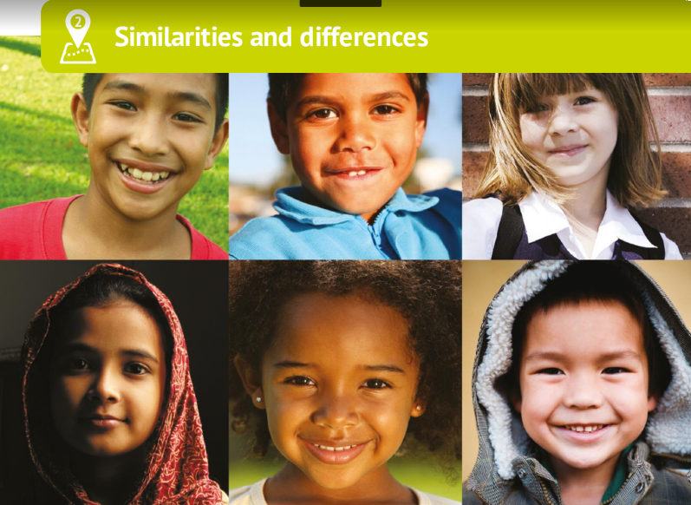

In Geography, the children will be:

• **Be able to use geographical terms such as symbol, key, map, aerial photo, globe and satellite image.**

• **Be able to use local maps to locate known features.**

• **Be able to make simple maps and plans of familiar locations.**

In History, we’ll be:

• Be able to gather information from simple sources.

• know about the main events, dates and characteristics of past societies.

In International learning goals, we’ll be:

• Be able to identify cultures that are different from but similar to their own.

• know that people in different countries have different traditions, celebrations and ways of living.

Religious Education

We will be learning about Christianity this term – specifically focusing on the Christmas and exploring the key question ‘Has Christmas lost its true meaning?’ Children will learn about the Christmas story and use it to evaluate whether or not Christmas has lost its true meaning.

PHSE – Celebrating differences

To respect differences.

Outcomes: Children will be able to:

Identify similarities and differences between themselves and others.

Appreciate themselves and others.

Give and receive compliments.

Physical Education – Swimming and Gymnastics

Year 3 will be swimming in the week beginning 16th December for one week with the aim of developing their confidence in water. They will also have Gymnastics every Monday to develop their coordination skills.

French

We will be learning simple greetings  
as well as continuing to learn numbers

in French.

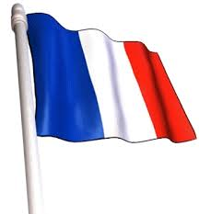

Science – Food and our Bodies

We will be learning about:  
-foods humans and animals eat, and what makes a healthy, balanced diet.  
-the different parts of our skeletal system.  
-bones, joints and muscles and how they help us move.

Parents How Can You Help?

**Maths and Spelling**: Please help your child to practise their times tables. This will really help them in their numeracy work. Also please help your child to complete their **MyMaths** homework. Spelling overview sheets have been sent home and every week children are also given spellings to practise.

**Reading:** Children are expected to read every night. Extra reading is always advised! Ask your child questions about what they have just read such as ‘Can you summarise the chapter?’, ‘Why do you think that character acted in that way?’, ‘Show me how you know that this character is not happy.’

**PE kit every Monday and they can take it home on Friday**

Computing: We are Bug Fixers

We will be learning how to program, recognise mistakes in our programming and fix mistakes using the programme Scratch!

Music

The whole class will be learning about  
bass and tone on the drums.