**Half-Termly Curriculum Overview for Year 3 Spring Term 1 January-February 2019**

**Mr Cush-Etter and Ms. Grundy**

Literacy

We will be exploring non-fiction texts this term – particularly focusing on two non-fiction texts: ‘George’s Marvellous Experiments’ and ‘Three Cheers for Women.’ Outcomes: Children will be able to:

Know the features of instructional and biographical non-fictional texts.

Write a clearly structured instructional text – telling someone how to do something.

Write a biography about a famous person of their choice using formal language.

Write in the correct tense (either present or past tense) for each non-fiction text.

Maths

To multiply and divide numbers using the 3, 4 and 8 times tables.

To multiply and divide 2-digit numbers by 1-digit numbers (e.g. 21 x 4) using partitioning and column method.

To recognise and compare the value of different amounts of money using pounds and pence

To add and subtract money, and to carry out practical activities involving calculating change.  
To read and interpret graphs including pictograms, bar charts and tables.



**WEEK AT A GLANCE!  
Monday and Friday**: PE **Friday**: Cooking (bring a clean food tub)

International Primary Curriculum (IPC)

Over the next 7 weeks we will be following a unit of work on a theme that focuses on “Active Planet: Earthquakes and Volcanoes”. During this unit we will be focusing on **Geography, Art and History.**

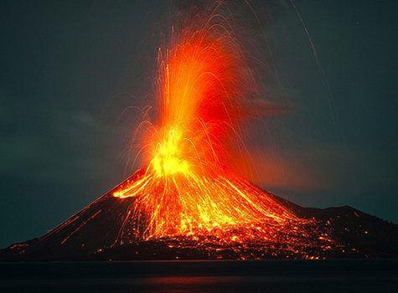

In Geography, the children will be:

• **able to use maps, atlases, globes and digital/computer mapping to locate countries where there are volcanoes (and where earthquakes occur) and find out why volcanoes and earthquakes occur.**

• **able to visit a museum to learn about volcanoes and earthquakes.**

• **able to** use the eight points of a compass, four and six-figure grid references, symbols and key to build their knowledge of the United Kingdom and the wider world.

In History, we’ll be:

• Be able to choose and use reliable sources to collect evidence about a volcanic eruption that took place in the past.

• be able to describe the main changes in a period of history.

In Art, we’ll be:

• Be able to improve their mastery of art and design techniques including drawing, painting and sculpture.

• know how to shape, form, model and construct using malleable and rigid materials.

Religious Education

We will be learning about Christianity this term – specifically focusing on ‘Jesus’ Miracles’ and exploring the key question ‘Could Jesus heal people?’ Children will explore some stories where Jesus healed people and use it to evaluate whether or not these were miracles (or was there another explanation?).

PHSE – Dreams and Goals

To identify their own dream or ambition.

Outcomes: Children will be able to:

Identify their own dream or goals.

Work in groups to solve a challenge.

Break down the challenge into a number of steps.

Physical Education – Swimming and Judo

Year 3 swimming will be for one week in the Summer Term (date will be disclosed in due time). They will however start Judo this term to develop their coordination, balance and grappling skills.

French

We will be learning about animals

whilst also consolidating our learning

of greetings, numbers and colours.

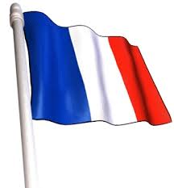

Science – Mirror Mirror

We will be learning:  
- To notice that light is reflected from surfaces.  
- To recognise that light from the sun can be dangerous.  
- To recognise how shadows are formed and to find patterns in the way that the size of shadows change.

Parents How Can You Help?

**Maths and Spelling**: Please help your child to practise their times tables. This will really help them in their numeracy work. Also please help your child to complete their **MyMaths** homework. Spelling overview sheets have been sent home and every week children are also given spellings to practise.

**Reading:** Children are expected to read every night. Extra reading is always advised! Ask your child questions about what they have just read such as ‘Can you summarise the chapter?’, ‘Why do you think that character acted in that way?’, ‘What type of text is this?’, ‘How might the character be feeling?’

**PE kit every Monday and they can take it home on Friday**

Computing: We are Communicators

We will be learning about how to use emails safely! Children will learn about what emails are, being safe using emails and practise writing them.

Music

The whole class will be learning about  
bass and tone on the drums.