Half-Termly Curriculum Overview for Year 5 Autumn Term 2 November/December 2019
Ms O’Reilly, Miss Safia and Ms Sharena

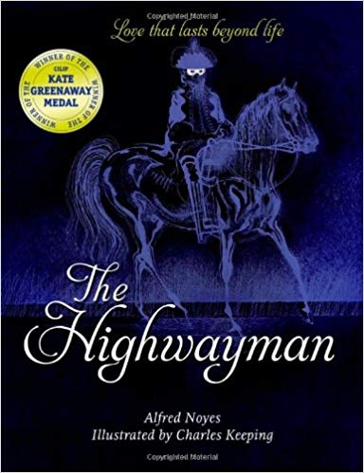
Literacy
This term we will be reading ‘The Highwayman’ as well as other narrative poems. We will be working in writing partners to then create our own narrative poem based on a short animation.
We will finish the half term reading ‘Journey to Jo’burg’ in the unit ‘Stories from other cultures’. We will also be learning about apartheid rule in South Africa before creating our own short story, set in South Africa.

Maths
*Identify multiples and factors, including finding all factor pairs of a number, and common factors of two numbers.
*Recognise and use square numbers and cube numbers as well as use the notation for squared (²) and cubed (³).
*Multiply and divide whole numbers by 10, 100 and 1000.
*Multiply and divide numbers mentally drawing upon known facts.
*Know and use the vocabulary prime numbers, prime factors and composite numbers.
*Establish whether a number up to 100 is prime and recall prime numbers up to 19.

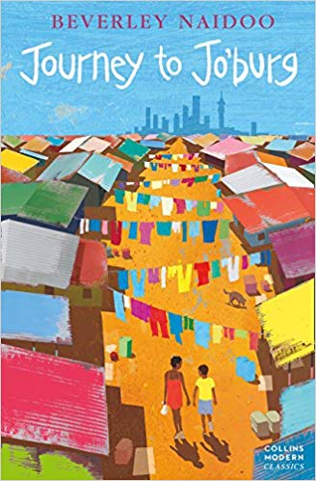

Important days:
Wednesday: CaN (please bring in a clean container) Thursday: PE Friday: Swimming
International Primary Curriculum (IPC)
Over the next 6 weeks we will be exploring the topic ‘Extreme Habitats’ “
During this unit we will be focusing on Science, Geography and Art.

We will be learning about the physical adaptations animals and plants have evolved to have in order to survive in extreme environments.
We will also learn why other plants and animals cannot survive in these habitats.
We will learn about animals like camels, polar bears and fish found in the deepest parts of our oceans.
We will also be exploring the threats posed to these habitats and what we can do to help.
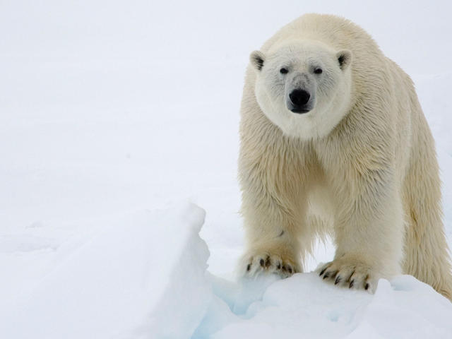 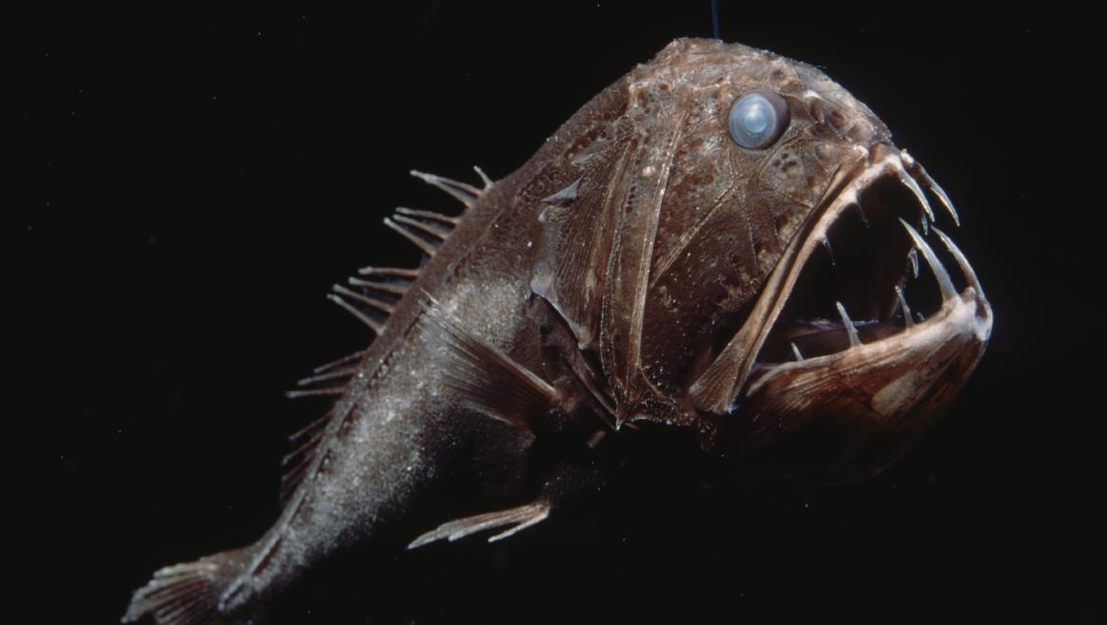 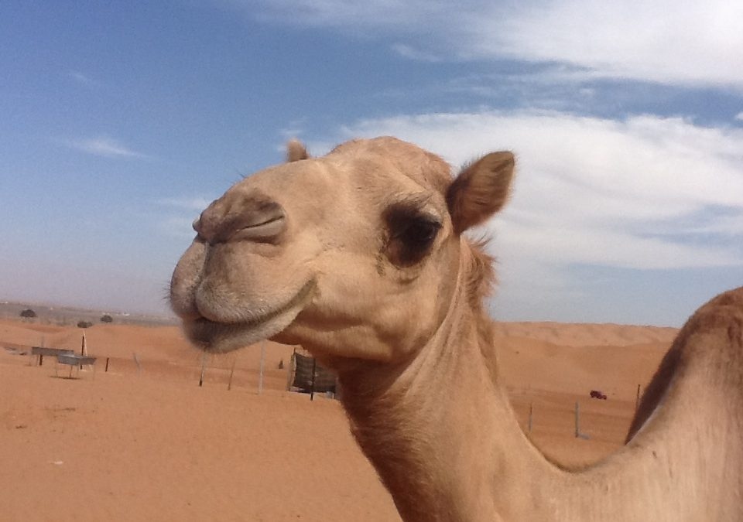

Religious Education
In RE this term, we will be exploring the key question of ‘Is the Christmas story true?’
We will be learning bout subjectivity and read different accounts of the Christmas story, discussing the differences and similarities between them. We will understand how stories can be true in different ways.

PHSE – Celebrating Difference

To know about my self-worth.
Outcomes:
Children will be able to:
Identify differences between us all.
Understand why differences sometimes cause conflict.

Physical Education- Hockey and Swimming

Please bring your PE kit on a Thursday and swimming kit (costume, towel and swimming hat) on a Friday!
Your child will not be allowed to swim without a hat.

French

We will be learning basic nouns and recognising the different genders used in French.
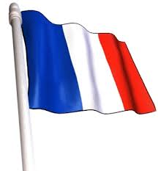

Computing: We are Cryptographers

We will be learning how to decipher codes such as Morse code, Semaphore and Caesar cipher.
Music
The whole class will be continuing their
learning of the drums with our instructor
Michael Thomas.
Parents: How Can You Help?
Maths: Please help your child to practise methods like column addition, subtraction and multiplication.
Reading: Children are expected to read every night. Extra reading is always advised! They are always keen to visit the school library, so please try to visit your local library too.
Homework: Each child should be logging onto their MyMaths and Times Table Rockstars accounts. Your child will be expected to read every night. There will not be regular homework set, but please do activities together at home such as cooking. We have a lot of skilled and talented chefs in our class!

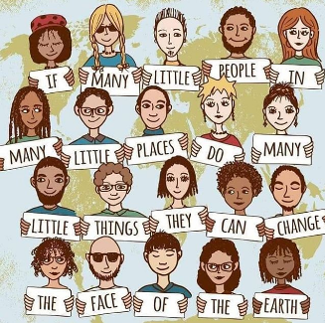
Science: Material World!
In Science this term, we will learn:
-about different materials and how they change.
-to test properties of materials.
-to recognise appropriate materials for
different jobs.
-to compare reversible and irreversible
changes.

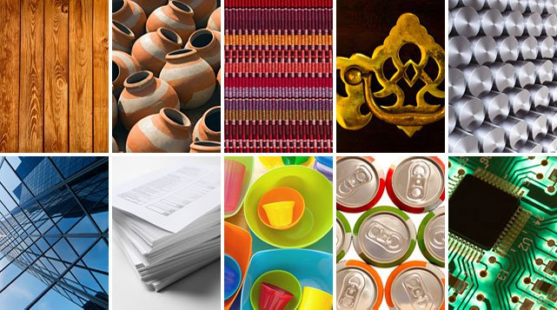

Year 5  Autumn Term 2 | Monday | Tuesday | Wednesday |  | Thursday | Friday
9:00 – 9:15 | Book check | Book check | Book check |  | Book check | Book check
9:15-9:45 | Guided Reading | Guided Reading | Guided Reading |  | Guided Reading | Guided Reading
9:45 – 10:45 | Literacy | Literacy | Literacy |  | Literacy | Literacy
10:45– 11:00 | Assembly | Assembly | Assembly |  | Assembly | Assembly
11:00 – 11:15 | Playtime | Playtime | Playtime |  | Playtime | Playtime
11:15 – 12:15 | Maths | Maths | Maths |  | 11:15-12 Maths | Maths
12:15 – 12:30 | Spellings | Spellings | Spellings |  | 12-12.30 Drumming | Spellings
12:30 – 1:30 | Lunch | Lunch | Lunch |  | Lunch | Lunch
1:30-1:45 | My Book | My Book | My Book |  | My Book | My Book
1:45 – 2:35 | Science | Computing | CaN | PE | RE | 1:30-2 Catch Up or  Reward Time
2:35 – 3:30 | PSHE | IPC | CaN | Spelling and  Handwriting | PE (Hockey) | Swimming
3.30 | Home time | Home time | Home time |  | Home time | Hometime

