Topic: The Great Fire of London

Outcomes:

We are learning about events beyond living memory that have made an impact nationally. Recall some facts about people and events before living memory.

Talk, write and draw about events from the past.

* Look at books, videos, photographs and artefacts to find out about the past.
* Use a timeline to place certain events- order a set of events.
* Tell stories about the past and discuss people of the past and why they might have acted as they did.

**Physical Education (PE)**

P.E will take place every Mondays (T-shirt, shorts or joggers) we are not changing for PE.

Cooking and Nutrition:

Children will be making toms & basil fusilli

SCIENCE

***Holiday***

In science we are learning all about Holidays. We will be able to;

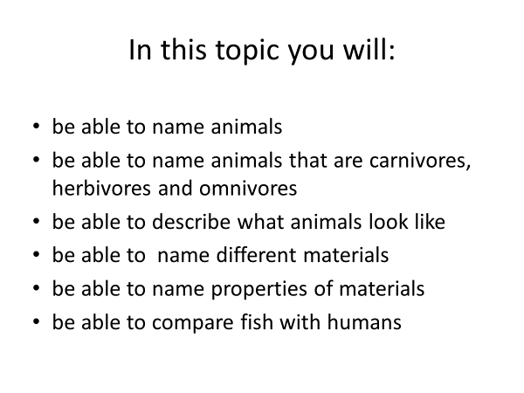

**PSHE: Changing me**

In this topic, children will be able to express how they feel when change happens. They will be able to understand and respect changes that they see in themselves.

**Religious Education:** Judaism- Rosh Hashanah and Yom Kippur

Key question:

Are Rosh Hashanah and Yom Kippur important to Jewish children?

Outcomes:

Children will be able to:

discuss what forgiveness means.

Children will learn to empathise with Jewish children by understanding what Rosh Hashanah and Yom Kippur means to them.

Parents How Can You Help?

**Maths**: Children need to learn how to count to and back from 50 from any given number.

Children need to learn how to count in 10s, 2s and 5s.

**Reading:** Please ensure you are doing lots of reading with your child and practising to write short or long sentences. This will allow them to improve and make their words and sentences better.

**Music:**

The children will continue to learn drumming.

**ICT:**

Year 1 will start a Coding unit.​

**Half-Termly Curriculum Overview for Year 1 Summer 2 June 2022**

**Ms Tania, Mr Hussain and Ms Brenda**

**Maths Focus**: **Place value (within 100)**

Outcomes:

Children will continue their learning on place value:

Children will start with numbers within 10, 20 and 50.

Use number track to support where needed.

They be able to count in 10s, 2s and 5s.

They will be able to compare two sets of objects using

language ‘more than’, ‘less than’ and ‘equal to’.

Children will be able to continue to count forwards and

Backwards within 100.

They will be partitioning numbers.

**Literacy Focus: Fantasy/ Sci-fi**

To be able to fuel imagination.

To be able to predict possible events in a narrative based on their experience of other texts.

To be able to record their learning during these sessions.

Outcomes:

Children will be able to:

Choose adjectives to carefully describe places and things in the story.

They will be able to use similes to help the reader imagine what they are describing.

Children will be able to read, compare and contrast a range of fantasy world settings from different text sources.

They will be able to identify objects found in settings that make them different from the world around us.